DEPARTMENT OF MINES AND ENERGY

QUEENSLAND

PRELIMINARY REPORT

TO

THE CHIEF INSPECTOR OF MINES

ON

FATALITY

PETER JAMES COMERFORD

MOUNT ISA MINES LIMITED
GEORGE FISHER PROJECT
LEAD SMELTER UPGRADE

14 JULY 2000

INVESTIGATING OFFICER: SERGIO CESPEDES
Electrical Inspector of Mines
Mount Isa
FILE REF: 30528/4/Sc

TABLE OF CONTENTS

1.0 Summary 3
2.0 Personal Details of Deceased 3
3.0 Management Structure and Relationships 3
4.0 Details of Mine 4
5.0 Notification 4
6.0 Preliminary Investigation 4
6.1 Sequence of events before accident 5
6.2 Accident scene after the accident 5
7.0 Preliminary Findings 6
Appendix 1 List of Persons Interviewed 7
Drawing 1.- Side view of the 223 spiked rolls crusher 9
Drawing 2.- Top view of the 223 spiked rolls crusher 10
PHOTOGRAPH 1 11
PHOTOGRAPH 2 12
PHOTOGRAPH 3 13
Photograph 4 14
PHOTOGRAPH 5 15

1.0 Summary

At approximately 1250 hrs on Friday 14 July 2000, Mr. Peter James COMERFORD, was a rigger directing the movement of a 15 ton overhead crane through a void which had been created between the top floor and the first floor of the Sinter Plant. The task being undertaken was to lift out a spiked roll crusher frame. The frame was hanging vertically from the overhead crane and just above the 223 level of Lead Smelter Sinter Plant. Mr. COMERFORD was struck by a bearing housing assembly that fell from the crusher frame a distance of approximately 3 metres.

Mr. COMERFORD was immediately given first aid by personnel working in the vicinity and a call requesting ambulance assistance was made at 12:50 hrs.

The Queensland Ambulance service attended the site of the accident and transported Mr. COMERFORD to the Mount Isa Base Hospital. He was pronounced dead on arrival at the hospital.

2.0 Personal Details of Deceased

Name | Peter James COMERFORD
Age | 31
Date of Birth | 13th November 1968
Occupation | Rigger
Address | 21 Nathan Street, Mount Isa 4825
Marital status | De Facto
Children | 3 daughters
Employer | A.E.T. Operations Pty. Ltd.
Injuries Sustained | Massive head injury
Location of Accident | Mount Isa Mines, Lead Smelter Sinter Plant, 223 Crusher level

3.0 Management Structure and Relationships

Mine Owner | Mount Isa Mines Limited
Project Management Lead Smelter Upgrade Shutdown | George Fisher Project, an integrated project team between Mount Isa Mines and Bateman Brown & Root
Construction Contractor working on the refurbishment of the Lead Smelter Sinter Plant | A.E.T. Operations Pty Ltd (providing labour and some supervision) and  Baulderstone / Hornibrook Pty Limited (providing management / supervision) (under an Agreement to Associate)

4.0 Details of the Mine

Name of Mine | Mount Isa Mines Limited (Lead Smelter)
Location | Mount Isa, Queensland
Address | Private Mail Bag  MOUNT ISA, QLD 4825
Mine Owner | Mount Isa Mines Limited (ABN 87 009 661 447)
Lease Number | ML8058
Registered Manager | Daniel Peter MCMANUS
Site Telephone Number | 07 4744 3740
Site Fax Number | 07 4744 2504

5.0 Notification

On Friday 14th July 2000 at approximately 1314 hours, Debbie WOOD of Department of Mines and Energy front desk received a telephone call from Daniel MCMANUS, Registered Manager of Mount Isa Mines George Fisher Project, Lead Smelter Upgrade Shutdown informing the department of a serious accident in the Sinter Plant. The message was immediately passed on Robert O’SULLIVAN, District Inspector of Mines who rang back Mr. MCMANUS and was informed that a rigger had been struck by a bearing housing and he had been taken by ambulance to Mount Isa Base Hospital.

Mr. O’SULLIVAN instructed me to go immediately to the site and secure the accident scene. He then proceeded to notify the relevant persons within the Department of Mines and Energy.

6.0 Preliminary Investigation

I arrived to the Lead Smelter offices approximately 13:20 hrs and went immediately to the Sinter Plant 223 spiked rolls crusher level, where I met:

Tony MCPAUL | Mount Isa Mines Metallurgical Plants Manager
Malcolm LEWIS | General Manager George Fisher Development
Daniel MCMANUS | Registered Manager George Fisher Lead Smelter Shutdown

I requested that all personnel leave the accident scene and that all levels of the Sinter Plant above and below the accident scene be barricaded off to preserve evidence.
I then took some initial photographs and went to the Lead Smelter office building to ring Mr. O’SULLIVAN to inform him of the current situation.

At the Lead Smelter office I met four police officers, who informed me they were waiting for the arrival of two further police officers with some equipment prior to their visit of the accident scene.

A few minutes later: Robert O’SULLIVAN, District Inspector of Mines, Hermann FASCHING, Inspection Officer and Peter MCGARVEY, District Workers Representative. Arrived. I gave them a brief explanation of the situation and shortly following this, Police Senior Constables Brett SWEENEY and Phillip BRIDGE arrived.

Then accompanied by Malcolm LEWIS and Tony MCPAUL an inspection of the accident site including upper levels and overhead crane of the Sinter Plant took place. During this inspection Senior Constable BRIDGE took photographs and Senior Constable SWEENEY made some sketches and notes.

The information contained in subsections 6.1, and 6.2 is included as a result of direct observation and or statements from witnesses.

6.1 Sequence of events before accident

- The work being undertaken by A.E.T. Operations on the 223 spiked rolls crusher was part of the overall activities associated with the George Fisher Project Lead Smelter upgrade.
- In shifts prior to the accident two attempts were made to lift the 223 spiked rolls crusher out in one piece. A decision was then made to disassemble the crusher and lift it out in pieces as the total weight of the crusher exceeded the capacity of available cranes.
- The previous shift (night shift) had commenced the disassembly of the crusher and Mr. COMERFOR and crew had continued this disassembly during their shift prior to the accident
- During the day shift the crusher had been disassembled to a point where only the crusher frame and four bearing housing assemblies remained. The intention was to lift this remaining portion of the crusher out in one piece.

6.2 Accident scene after the accident

- The crusher frame was hanging vertically at the end of the 223 level platform and was slung to the MIM 15 ton overhead Crane (the crane is located on the top level of the Sinter Plant).
- Two of the bearing housing assemblies had fallen from the crusher frame shortly after the crusher frame had been lifted to the vertical position.
- The rigger (Peter COMERFORD) who was standing on the north-western corner of the 223 level directing the overhead crane driver using hand signals was struck by one of the bearing housing assemblies when it fell from the crusher frame.
- The other bearing housing assembly fell to the floor of the 223 level without causing injury.

7.0 Preliminary Findings

- The crew was unaware that the bearing housing assemblies could detach and fall from the crusher frame.

Investigation will continue and a Final Report will be forwarded in due course.

SERGIO CESPEDES
Inspector of Mines (Electrical)
Northern Regional Office - Mount Isa

Appendix 1 List of Persons Interviewed

NAME | OCCUPATION | ROLE
Michael John GATTY | Supervisor (A.E.T. Operations) | Day shift Supervisor working on the tip end of Sinter Machine (top level), observing the 223 crusher lifting.
Glen Anthony CANNON | Boilermaker (A.E.T. Operations) | Dayshift Leading Hand of crew removing the crusher frame
Gary Michael WRIGHT | Boilermaker (A.E.T. Operations) | Day shift crew working on 223 level. He and Cannon cut 700 mm of crusher frame
Jason Thomas PINCOTT | Mechanical Supervisor (A.E.T. Operations) | Dayshift Supervisor of crew removing the 223 crusher frame.
James Keith SANDERSON | Rigger (A.E.T. Operations) | Dayshift part of crew removing the 223 crusher frame
Torren Aziz BOCOS | Safety Officer (A.E.T. Operations) | Dayshift and part of the crew removing the crusher
Daryl John WILLIAMS | Boilermaker (Baulderstone Hornibrook) | Dayshift disassembling and removing crusher
Anthony Paul ROONEY | Fitter and Turner (Baulderstone Hornibrook) | Nightshift removing the upper part of spiked roll bearings assemblies
Stuart James WILTON | Supervisor (Baulderstone Hornibrook) | Nightshift responsible for Sinter Plant work
Kevin Rahin BOCOS | Director of A.E.T. Operations | Co-ordinating main jobs on Sinter Plant.
Michael Robert BAKHASH | Safety Advisor (George Fisher Project) | Nightshift, Safety in general during the development of the Lead Smelter project on behalf of George Fisher Project management team
David John RYAN | Safety Advisor (A.E.T. Operations) | Nightshift, he wrote a lift procedure for 223 crusher
Mark EZZY | Sinter Plant Maintenance Supervisor (MIM) | Dayshift. He passed information to contractors about the crusher weight based on drawings.
Barry HALL | Project Manager (Baulderstone Hornibrook) | To oversee the project in relation to contractual issues
Kerry James COE | Shutdown Manager (Bateman Australia) | To look after the works under Australian Standard AS2124
Terence John STOTT | Engineer / Project / Construction Manager (Bateman, Brown and Root) | Responsible for all the Lead Smelter Upgrade project on site.
Roger Adrian NICOLLS | Safety Advisor (Bateman, Brown and Root) | Dayshift, Safety in general during the development of the Lead Smelter project on behalf of George Fisher Project management team
Patrick ROCHFORD | Maintenance Superintendent (MIM) | Link with Bateman, Brown and Root, MIM production and maintenance and the contractors.
Stephen Roy LAMONT | Rigger / Dogman / Crane Driver (Baulderstone Hornibrook) | Nightshift, part of crew that attempted to lift the crusher in one piece the night before.
Peter John GILL | Operations Supervisor and crane driver (Brambles) | Dayshift, driving 70 tonne mobile crane day before accident.
John Robert HART | Crane Operator (Epoca) | Nightshift, operating 110 mobile crane night before accident
Peter Francis McAllister MCDOUGALL | Fitter and Turner (MIM) | Isolated and tagged out Sinter Plant 15 ton overhead crane
Duncan Boon Guy TALBOT-SCOBIE | Security Officer (Chubb Security) | Nightshift, he saw a person accessing restricted area.

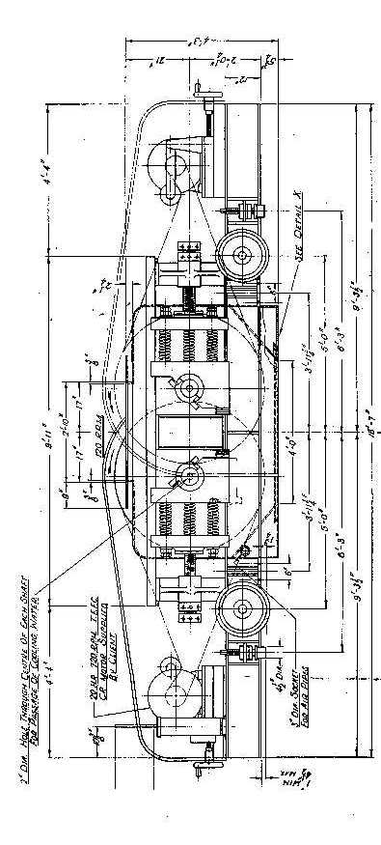
Drawing 1.- Side view of the 223 spiked rolls crusher

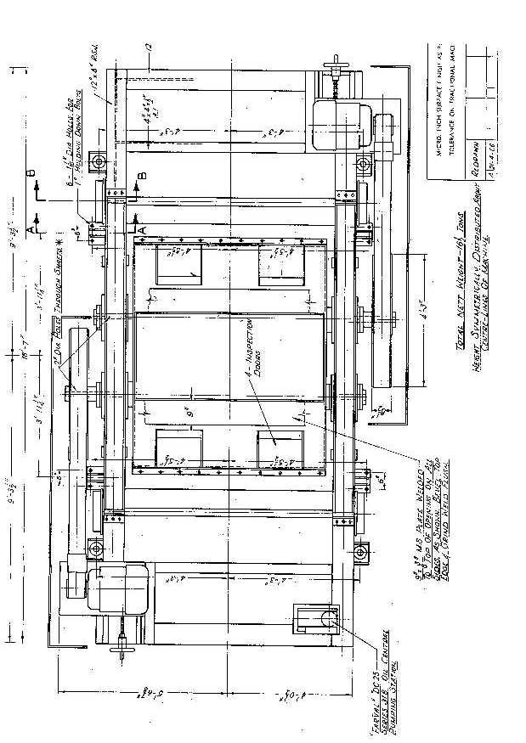
Drawing 2.- Top view of the 223 spiked rolls crusher

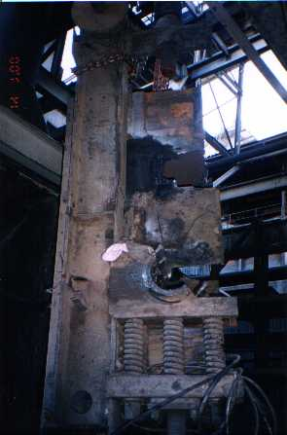
PHOTOGRAPH 1

CRUSHER FRAME HANGING FROM THE MIM 15 TON OVERHEAD CRANE

PHOTOGRAPH 2

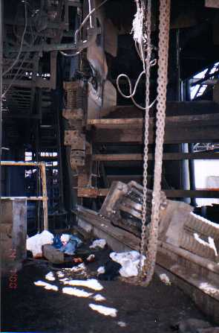

SHOWING CRUSHER FRAME BEARING BLOCK ASSEMBLY AND THE FLOOR AREA WHERE MR. COMERFORD WAS STANDING

PHOTOGRAPH 3

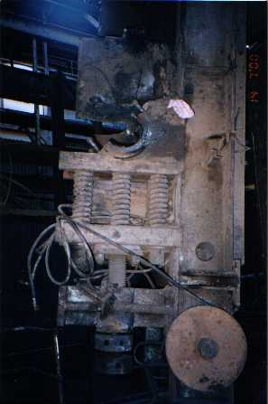

ARRANGEMENT OF BEARING HOUSING ASSEMBLY

Photograph 4

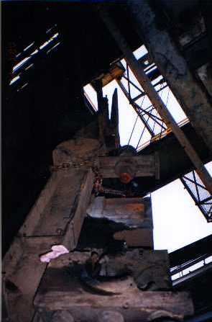

VIEW OF THE CRANE CONTROL CABIN THROUGH THE VOID FROM 223 LEVEL

PHOTOGRAPH 5

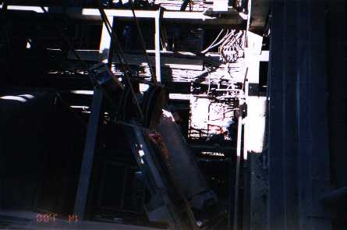

ACCIDENT SCENE FROM TOP LEVEL, NORTH WESTERN CORNER OF THE VOID

