FATALITY

PETER JAMES COMERFORD

MOUNT ISA MINES LIMITED
LEAD SMELTER SINTER PLANT

14 JULY 2000

DEPARTMENT OF MINES AND ENERGY

QUEENSLAND

Mines Regulation Act 1964

INVESTIGATING OFFICER’S REPORT

TO

THE CHIEF INSPECTOR OF MINES

ON

INVESTIGATING OFFICER: RICHARD HORSBURGH
Mechanical Inspector of Mines
Mareeba District
Northern Region

DATE: October 2000
FILE REF: 30528/4/RH

TABLE OF CONTENTS

PAGE
1.0 SUMMARY………………………………………………………………………3
2.0 NOTIFICATION……………………………………………………...………….3

3.0 INVESTIGATION…………………………………………………..…………...3

3.1 INVESTIGATION AT ACCIDENT SCENE…………………..……………..3

3.2 INVESTIGATION AT LEAD SMELTER WORKSHOP…………………....6

3.3 EXAMINATIONAL AT DEPARTMENTAL REGIONAL OFFICE………...6

4.0 FINDINGS……………………………………………………………………….7

1.0 SUMMARY

I carried out an investigation at the accident scene and subsequently at other locations to gather and record the physical evidence that resulted during a fatal accident to Peter James COMERFORD. This accident occurred at approximately 1248 hours on14 July 2000 on 223 Level of the Sinter Plant that is part of the Lead Smelter at Mt Isa Mine. He was struck by a bearing housing assembly that fell from a spiked rolls crusher frame that was suspended from an overhead travelling crane.

My report concentrates on the bearing housing assembly that struck Peter James COMERFORD.

2.0 NOTIFICATION

At approximately 1700 hours on Friday 14 July 2000 Roger BILLINGHAM, Deputy Chief Inspector of Mines notified me that there had been a fatal accident in the Lead Smelter Sinter Plant at Mt Isa Mine. He requested me to attend the accident scene as soon as possible.

3.0 INVESTIGATION

3.1 INVESTIGATION AT ACCIDENT SCENE

This description is based on evidence I sighted on 15, 16, 17 and 18 July 2000 and photographs taken on 14,15 and 16 July 2000 by the Mines Inspectorate. I was assisted on 15, 16 and 17 July by Hermann FASCHING, Inspection Officer and on all of the days by Peter McGARVEY, District Workers Representative. Other persons who accompanied us during the investigations are listed in the Record Book entries included in the main body of the report.

Reference is made to bearing housing assemblies in this report and for example the south western bearing housing assembly is outlined in red in Sketch 1, showing the suspended rolls crusher frame. This sketch and others that follow are views from the western side looking east. The assembly consists of the bearing that supports the rolls crusher shaft and locates the compression springs, six compression springs, a 100 mm thick plate that locates the other end of the compression springs, the take-up screw cover plate and all the associated nuts and bolts that hold the assembly together.

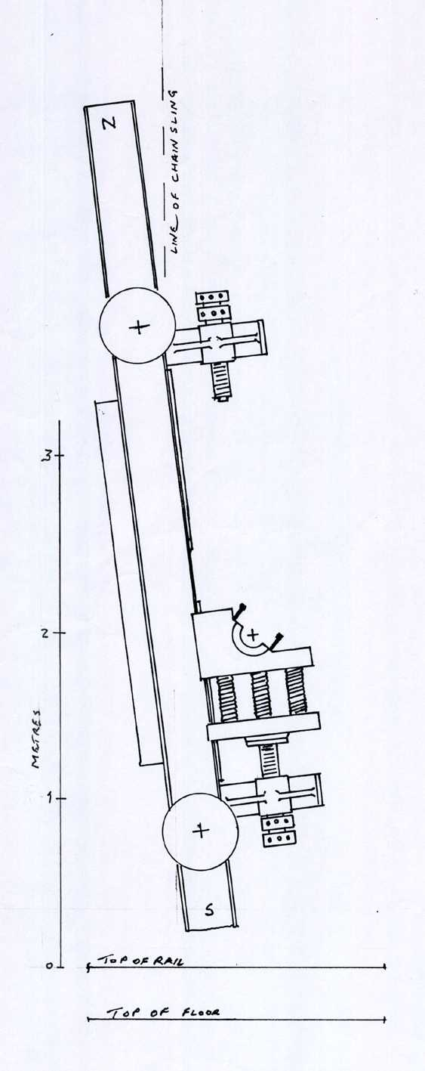
The rolls crusher frame was suspended by a 15 ton overhead travelling (OHT) crane MIM No M 6009. The frame was hanging slightly off vertical and had also pivoted off square from the two rails in a clockwise direction when viewed from above. A 2-legged chain sling was fitted to the hook of the OHT crane and this chain sling was attached to the crusher frame at the north end. The two southern bearing housing assemblies were still on the rolls crusher frame as were the four rail travel wheels and the four take-up screw assemblies. The take-up screws for each bearing housing assembly had recently been backed off approximately 15mm.

If reference is made to Jaques drawing No G 256 in the appendix of main body of the report details are shown of the following itemised parts that were on the 223 floor level:

- the two northern bearing housing assemblies
- two top channels item 51
- two fabricated columns, item 49
- various adjusting shims, items 25 to 27
- one bearing outer labyrinth seal
- four bearing housing caps
- part of the south end of the frame, item 86
- various nuts and bolts
- four rail clamps

The of the northern bearing housing assemblies was lying against the western rail of the rolls crusher and the other bearing housing assembly was lying on a sub-frame in between the rails. There was blood on the floor beside the western rail towards the northern end.
SKETCH 1.

There were fresh impact marks on both of the northern bearing housing assemblies that showed that they had both recently fallen. On the eastern side two impact marks on the north bearing housing assembly were matched by marks on the rolls crusher sub-frame just inside the east rail.

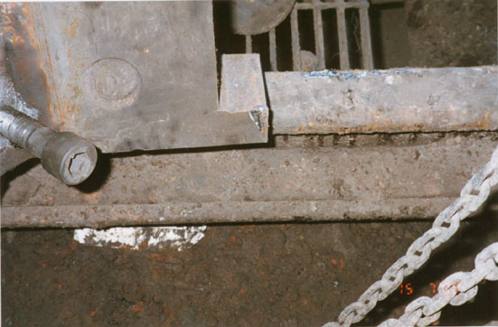
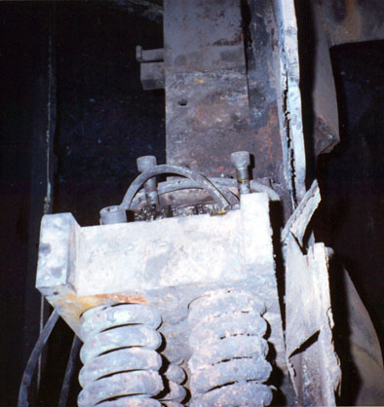

Film No. 5, Photograph No.13
Film No. 7, Photograph No. 5A

On the western side there was an impact mark on the north western bearing. Film No 5, Photograph No 13 shows a mark on the corner of the bearing as it is lying on the western rail. No corresponding impact point was found at floor level or sub-frame level. However there was an impact mark on the south western bearing that could have been the point of contact for the two assemblies. This mark is shown on Film No 7, Photograph No 5A and is in the foreground on the top edge of the bearing. The probable impact of the north western bearing on the south western bearing is shown on Sketch No 4.

There were also scuff marks along the inside flange of the west rail adjacent to the north western bearing housing assembly as it lay against the rail. I was unable to determine how these were made.

From the general number and size of the nuts and bolts at the accident scene it was apparent that the two top channels, the two fabricated columns and the four bearing housing caps had been removed from the rolls crusher frame prior to it being lifted into a near vertical position by the OHT crane.
The spiked rolls were not at the accident scene.

No evidence was found to establish how the bearing outer labyrinth seal had come to be on the floor. This outer labyrinth seal had been fitted to the north eastern bearing housing and would have been located but not held in place by a split ring. It was possible for it to fall out when the rolls crusher frame was lifted into a near vertical position or following an impact on the bearing housing assembly.
The four rail clamps did not look as if they had been used for some time. The rolls crusher is able to be moved along the two rails for maintenance purposes. My understanding is that the rail clamps are fitted to the roll crusher side members just inside the wheels. The crusher is then raised using the four jacking screws to lock it against the clamps.

At the southern end of where the rolls crusher had been installed there was a chain block hanging down. It was still attached to the southern end of the rolls crusher frame that had been cut off using oxy-acetylene. Further to the north there were two chain blocks hanging down, each just outside the east and west rails. On the western side, the length of played out chain plus its hook was such that it could be easily attached to the bottom the suspended rolls crusher frame on the western side. Similarly the eastern chain could be attached to the bottom of the eastern side at the same time.

The accident scene was viewed early on the evening of 16 July 2000 to gain an appreciation of the lighting conditions that existed on nightshift. The lighting on the 223 level was adequate and the visibility between this level and the crane cabin was also satisfactory.

A pair of Motorola MTX 838 handheld radios were checked for the level of communication between the crane cabin and the 223 level and vice-versa. These handheld radios were similar to those available at the time of the accident. The communication was made between Peter McGARVEY, District Workers Representative, and Kerry COE, MIM Shutdown Manager, in my presence. The communication was clear.

3.2 INVESTIGATION AT LEAD SMELTER WORKSHOP

This description is based on evidence I sighted and photographs I took on 20 July 2000. I was assisted by Mr Peter McGARVEY, District Workers Representative.

The rolls crusher frame together with the component parts still attached was taken to the Lead Smelter Workshop at Mt Isa Mine for further examination. The two northern bearing housing assemblies were also taken there. It was now possible to make close examination of parts that had been previously out of reach.

Jaques drawing No GY24, which is in the appendix of the main of the report, shows on the right hand side, a circular plate that is welded and become integral to the take up screw. This plate is held captive in the back of the bearing housing assembly by the take-up screw cover plate. As the take-up screw is turned the bearing housing assemblies are pulled or pushed along the slides on top of the main side members of the frame in order to adjust the gap between the two rolls. The welding that had at some time secured the circular plates to their respective northern take-up screws was broken.

The distance that the take up screws had been wound back was 20 to 25 mm which compares with the approximate 15mm measured when the rolls crusher frame was still hanging on the OHT crane. The take up screw cover plate is 25mm thick and so the amount of backing off would not have revealed that the weld was broken.
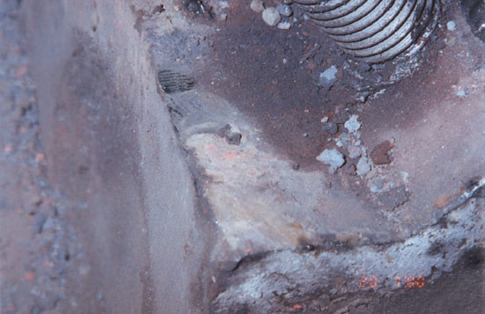

Further evidence of how the north western bearing housing assembly had fallen was determined by the fact that the head of an Allen screw had impacted the south western bearing. This mark matched the head of the Allen screws that had been put back into the north western bearing after its bearing housing cap had been removed. - refer to Film No 7, Photograph No 7A. Sketch No 3 shows the position of the bearing housing assembly at this impact point.
Film No.7, Photograph 7A.

3.3 EXAMINATION AT DEPARTMENTAL NORTHERN REGIONAL OFFICE

I examined the two northern take-up screws on 3 August 2000 at the office of the Department of Mines and Energy in Mt Isa.

It is my view that the welds now evident were undertaken some time subsequent to the original welds. The welds inside the two circular plates now had fresh marks on them where the end of take-up screws had turned relative to them. My conclusion was that the welds were broken at the commencement of backing off the take-up screws during the dismantling of the crusher or broken on some previous occasion.

4.0 FINDINGS

From the evidence gathered during the course of my investigation I conclude that the north western bearing housing assembly fell from its usual location on the rolls crusher frame. This occurred some time after the partly dismantled crusher was lifted into a near vertical position by the OHT crane. Just prior to falling the bearing housing assembly was held in position by the slide along its base and the spigot at the end of the take-up screw and possibly some encrustation. It could not begin its toppling motion until the assembly had fallen sufficiently for the spigot to be clear of the take-up screw cover plate (see Sketch No. 2)

My assessment of the mode in which the bearing housing assembly fell is shown in the diagrams below and is based on the impact points found during the investigation at the scene and in the Lead Smelter Workshop.
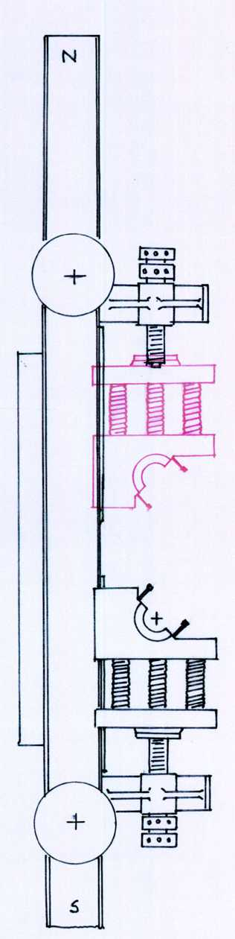
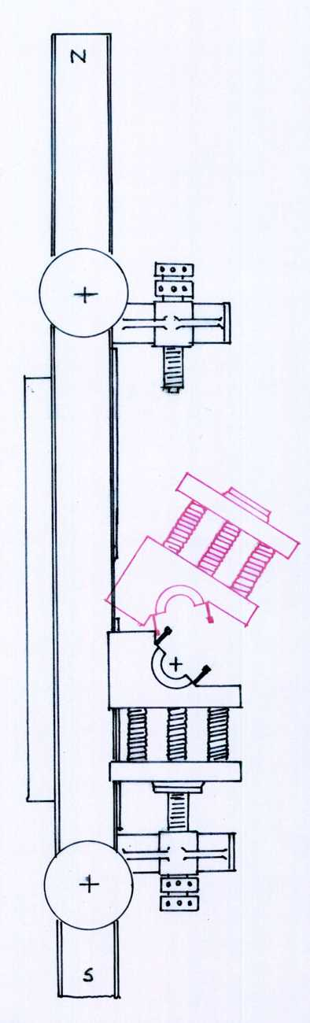
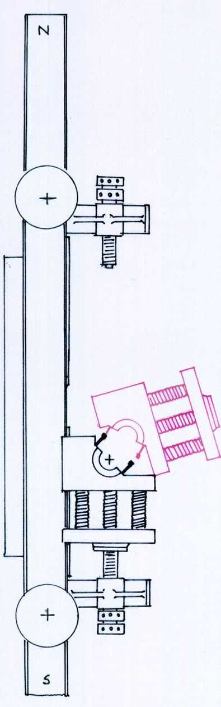
Sketch 2.
Sketch 3.
Sketch 4.

Richard Horsburgh
Mechanical Inspector of Mines
Northern Region

