FATALITY

PETER JAMES COMERFORD

MOUNT ISA MINES LIMITED
LEAD SMELTER SINTER PLANT

14 JULY 2000

DEPARTMENT OF MINES AND ENERGY

QUEENSLAND

Mines Regulation Act 1964

INVESTIGATING OFFICER’S REPORT

TO

THE CHIEF INSPECTOR OF MINES

ON

INVESTIGATING OFFICER: SERGIO CESPEDES
Inspector of Mines (Electrical)
Mount Isa District
Northern Region

DATE: October 2000
FILE REF: 30528/4/Sc

TABLE OF CONTENTS

1.0 SUMMARY 4
2.0 PERSONAL DETAILS OF DECEASED 4
2.1 FATALLY INJURED PERSON 4
3.0 MANAGEMENT STRUCTURE AND RELATIONSHIPS 5
4.0 MINE DETAILS 5
5.0 NOTIFICATION 6
6.0 INVESTIGATION 6
6.1 PRELIMINARY INVESTIGATION AND SITE INSPECTION 6
6.1.1 Inspection of the 223 Crusher Level 7
6.2 SECOND INSPECTION TO THE ACCIDENT SITE 8
6.3 DESCRIPTION OF ACTIVITIES CARRIED OUT ON 223 LEVEL 8
6.3.1 Tuesday 11 July 2000 dayshift (0700 hrs. 11/7 to 1900 hrs. 11/7) 9
6.3.2 Tuesday 11 July 2000 nightshift (1900 hrs. 11/7 to 0700 hrs. 12/7) 9
6.3.3 Wednesday 12 July 2000 dayshift (0700 hrs. 12/7 to 1900 hrs 12/7) 9
6.3.4 Wednesday 12 July 2000 nightshift (1900 hrs. 12/7 to 0700 hrs. 13/7) 9
6.3.5 Thursday 13 July 2000 dayshift (0700 hrs. 13/7 to 1900 hrs. 13/7) 9
6.3.6 Thursday 13 July 2000 nightshift (1900 hrs. 13/7 to 0700 hrs. 14/7) 10
6.3.7 Friday 14 July 2000 dayshift (0700 hrs. 14/7 to 1900 hrs. 14/7) 11
6.4 SCOPE OF WORK 15
7.0 FINDINGS 15
7.1 SCOPE OF WORK 15
7.2 JOB SAFETY ANALYSIS / RISK ASSESSMENT 15
7.3 REMOVAL OF THE CRUSHER IN ONE PIECE 16
7.4 COMMUNICATION 16
7.4.1 Status of work information 16
7.4.2 Communication between Riggers and Crane Drivers 16
7.5 UNDERSTANDING OF THE ACTIVITY / EQUIPMENT 16
7.6 FAILURE OF THE ADJUSTING SCREW END PLATES 17
7.7 SUPERVISION 18
7.8 ROLE OF SAFETY OFFICER 18
8.0 CONCLUSIONS 18
9.0 RECOMMENDATIONS 19
9.1 RECOMMENDATION NO. 1 19
9.2 RECOMMENDATION NO. 2 19
9.3 RECOMMENDATION NO. 3 19
9.4 RECOMMENDATION NO. 4 19
9.5 RECOMMENDATION NO. 5 19
9.6 RECOMMENDATION NO. 6 19
APPENDIX 1 STATEMENTS 20
APPENDIX 2 PHOTOGRAPHS 22
2.1 Police photograph No. 9 Accident scene from south west 23
2.2 Police photograph No. 12 North west bearing assembly from north west corner 24
2.3 Police photograph No. 33 Bearing housing assembly on west rail 25
2.4 Police photograph No. 36 Looking up underneath of 223 level north west corner 26
2.5 Police photograph No. 19 Accident scene and south east bearing housing assembly
on 223 level. 27
2.6 Police photograph No. 10 223 crusher frame from south east. 28
2.7 Police Photograph No. 11 North west bearing housing assembly 29
APPENDIX 3 MANUFACTURER’S LETTER CONCERNING THE 223 SPIKED
ROLLS CRUSHER 30
APPENDIX 4 REPORTS BY: 31
4.1 Inspections X-Ray & Testing Pty Ltd (IXT). 32
4.2 Bullivants Lifting & Safety Specialists 33
4.3 Mechanical Inspector of Mines 34
APPENDIX 5 DOCUMENTATION ON: 35
5.1 A.E.T. Operations Pty Ltd / Baulderstone Hornibrook Health & Safety
Management Plan 36
5.2 George Fisher Project – Contract No. BBK816-M-CC-32C, Smelter Sinter
Plant Structural Mechanical 37
5.3 Lead Smelter Y2000 Shutdown – Risk Assessment 38
5.4 Lift Procedure – Removal of 223 Crusher by A.E.T. / BH 39
5.5 Manufacturer - Jaques Bros. Ltd. Engineers – Richmond Victoria drawings 40
5.6 Simon-Carves (Australia ) Pty. Limited – Sydney. N.S.W drawing 41
5.7 Documents given to Glen CANNON by Kevin BOCOS on Tuesday 11 July 2000 42
5.8 Job Safety Analysis for the removal of 223 crusher by Torren BOCOS,
A.E.T. Operations Pty Ltd Safety Adviser 43
APPENDIX 6 REGISTERED MINE MANAGER’S REPORT 44
APPENDIX 7 INVESTIGATION DOCUMENTATION 45
7.1 Post mortem examination report (Form 10) 46
7.2 Post mortem examination certificate (Form E) 47
7.3 Report concerning death (Form 4) 48
7.4 Pathology report 49
7.5 Toxicology report 50
7.6 Death certificate 51
APPENDIX 8 RECORD BOOK ENTRIES 52
APPENDIX 9 APPOINTMENT OF REGISTERED MINE MANAGER 53
APPENDIX 10 PRELIMINARY REPORT TO THE CHIEF INSPECTOR OF MINES 54

1.0 SUMMARY

At approximately 1248 hrs on Friday 14 July 2000, Mr Peter James COMMERFORD, a rigger, was directing the lift of a crusher frame that was being lifted by an overhead travelling crane in the Sinter Plant of the Mount Isa Mines Lead Smelter. He was struck and fatally injured by one of the two bearing housing assemblies that fell from the crusher frame.

At the time of the accident Mr Peter James COMMERFORD was part of a contracting crew who were tasked with the removal of a Spiked Rolls Crusher from the 223 level of the Sinter Plant. This work was being undertaken as part of a Lead Smelter upgrade. Prior to the accident attempts had been made to remove the crusher in one piece, however this was unsuccessful and it was then decided to strip the crusher and remove it in pieces.

Most of the major components had been removed from the crusher frame prior to the final lift. It was during this final lift of the crusher frame that two of four bearing housing assemblies (which support the shafts of the spiked rolls) dislodged from the frame and fell approximately 3 metres to the floor. One fell harmlessly to the floor missing all persons, the other struck Mr Peter James COMMERFORD.

Personnel working in the vicinity immediately gave Peter COMERFORD first aid and a call requesting ambulance assistance was made at 1249 hrs.

The Queensland Ambulance Service attended the site of the accident and transported Peter COMERFORD to the Mount Isa Base Hospital. He was pronounced dead on arrival at the hospital.

2.0 PERSONAL DETAILS OF DECEASED

2.1 FATALLY INJURED PERSON

Name | Peter James COMERFORD
Age | 31
Date of Birth | 13 November 1968
Occupation | Rigger
Qualifications | Workplace Health and Safety certificates:  - Rigger/Dogger – No. 1644306  - Bridge/Gantry Crane – No. 1636374  - Forklift – No. 1590890  - Work Platform – No. 1629001  - Electrical Mechanics and Fitting Apprenticeship, completed 24 July 1989.
Address | 21 Nathan Street, Mount Isa Qld 4825
Employer | A.E.T. Operations Pty. Ltd.
Employer’s Address | 4 – 6 Duke Street – Mount Isa Qld 4825
Employer’s Telephone Number | (07) 4749 1754
Employer’s Fax Number | (07)4749 1487
Injuries Sustained | Massive head injury, total dislocation of left knee.
Location of Accident | Mount Isa Mines, Lead Smelter Sinter Plant, 223 Crusher Level.

3.0 MANAGEMENT STRUCTURE AND RELATIONSHIPS

The work being carried out in the Lead Smelter at the time of the accident was part of an upgrade of this facility to enable it to treat the ore from the George Fisher Mine.

This work was being co-ordinated and managed by the George Fisher Project (GFP). This is a project team consisting of personnel from Mount Isa Mines Limited and Bateman Brown and Root. The Registered Manager for this project was Mr Daniel Peter McMANUS who was employed by Bateman Brown and Root. Mr McMANUS reported to Mr Terence STOTT, who was the Construction Manager employed by Bateman Brown and Root. Mr STOTT in turn reported to Mr. Malcolm LEWIS, who is the General Manager of the George Fisher Project for Mount Isa Mines Limited. GFP were responsible for the administration of contracts that were issued for the various parts of the Lead Smelter Upgrade work. These contracts were issued to the various contractors by Mount Isa Mines Limited.

The contract for the work in the Sinter Plant of the Lead Smelter was issued to Baulderstone Hornibrook Pty Ltd (contract No. BBK816-M-CC-32C). The scope of work of this contract set out the requirements for work associated with the supply, installation, repairs and refurbishment of the Sinter Machine, Spiked Rolls Crusher, Apron Feeder, Vibrating Feeders and associated Hygiene equipment in the Lead Smelter. To enable Baulderstone Hornibrook to undertake this work it entered into an Agreement to Associate with A.E.T. Operations Pty Ltd.

Under the Agreement to Associate, Baulderstone Hornibrook was to provide financial and managerial resources and A.E.T. would provide supervision and labour to physically carry out the work. This included for both parties to be responsible for:

- the day to day performance of its Party Obligations;
- the appointment of subcontractors and to monitor their performance;
- the supply of their own plant, machinery, tools, labour and materials and whatever else was necessary;
- furnishing whatever resources were necessary to carry out its Party Obligations.

At the time of the accident Mr Peter James COMMERFORD was employed as a rigger by A.E.T. Operations Pty Ltd.

4.0 MINE DETAILS

Name of Mine | George Fisher Surface and Underground Construction Area
Location | Mount Isa, Queensland
Address | Private Mail Bag  MOUNT ISA, QLD 4825
Mine Owner | Mount Isa Mines Limited (ABN 87 009 661 447)
Lease Number | ML8058
Registered Manager | Daniel Peter McMANUS, employed by Bateman Brown and Root
Site Telephone Number | 07 4744 3740
Site Fax Number | 07 4744 2504

5.0 NOTIFICATION

On Friday 14 July 2000 at approximately 1314 hours at the Mt Isa office of the Department of Mines and Energy, Miss Debbie WOOD, District Tenures Officer received a telephone call from Mr Daniel McMANUS. Mr McMANUS informed her of a serious accident in the Sinter Plant of the Mount Isa Mines Lead Smelter.

The message was immediately passed on to Mr Robert O’SULLIVAN, District Inspector of Mines who rang Mr Daniel McMANUS and was informed that a bearing housing assembly had struck a rigger and that he had been taken by ambulance to Mount Isa Base Hospital.

Mr Robert O’SULLIVAN immediately instructed me to go to the site and secure the accident scene. He then proceeded to notify the relevant persons within the Department of Mines and Energy.

6.0 INVESTIGATION

6.1 PRELIMINARY INVESTIGATION AND SITE INSPECTION

On Friday 14 July 2000, I arrived at the Lead Smelter offices at approximately 13:20 hrs and immediately went to the Sinter Plant 223 spiked rolls crusher level where I met:

Tony McPAUL | Metallurgical Plants Manager Mount Isa Mines
Malcolm LEWIS | General Manager George Fisher Development
Daniel McMANUS | Registered Manager George Fisher Lead Smelter Upgrade

At this time I requested that all personnel leave the accident scene and that all areas of the Sinter Plant above and below the accident site be barricaded off to preserve the scene.

I then took some initial photographs and went to the Lead Smelter office to ring Mr Robert O’SULLIVAN to inform him of the current situation.

Outside the Lead Smelter offices I met four police officers, who informed me they were waiting for the arrival of two further police officers with some equipment prior to their visiting the accident scene.

A few minutes later, Mr Robert O’SULLIVAN, District Inspector of Mines, Mr Hermann FASCHING, Inspection Officer and Mr Peter McGARVEY, District Workers Representative arrived. I gave them a brief explanation of the situation. While this discussion was taking place, Senior Constables Brett SWEENEY and Phillip BRIDGE of the Mount Isa Police arrived.

Then accompanied by Mr Robert O’SULLIVAN, Mr Hermann FASCHING, Mr Peter McGARVEY, Mr Malcolm LEWIS, Mr Tony McPAUL, Senior Constable Brett SWEENEY and Senior Constable Phillip BRIDGE an inspection of the accident site including upper levels and overhead crane of the Sinter Plant took place. During this inspection Senior Constable BRIDGE took photographs of the accident scene and other levels near the void through which the crusher frame was being lifted and Senior Constable SWEENEY made some sketches and notes.

The accident occurred at the northern end of the 223 level in the Sinter Plant, it is the second of five levels (see Lead Smelter Sinter Plant drawing No. 163-6-3030 in appendix 5.7), and has a surface area of approximately 39 m². It is on this level that the spiked rolls crusher is normally situated. This crusher is the first of a series of crushers used to crush sinter material from the sinter machine. (Sinter is a fused agglomerate of lead, zinc, iron, sulphur, limestone and silica.

Prior to the accident the 223 spike rolls crusher and associated steelwork had been stripped.

6.1.1 Inspection of the 223 Crusher Level

I inspected the 223 Crusher Level area and noted the positions of various items of equipment and machinery.

6.1.1.1 Floor area

Inspection of the floor area revealed:

- the floor area was open as the crusher and associated steel work had been removed (see appendix 2.1 Police Photograph No. 9);
- at the southern end on the east and west side were two channel sections of approximately 3020 mm long by 229 mm wide;
- in the centre of the floor area were two sections of rail which ran in a north south direction;
- between these two sections of rail, the floor was lower than the main floor of the crusher level;
- on the northern end on the east and west side were bearing caps and associated bolts;
- also on the northern end on the east and west side were two fabricated columns;
- hand rails on the northern end had been removed to clear the way to lift the crusher;
- one bearing housing assembly was on the inner side of east rail northern end and the second bearing housing assembly was on west rail northern end;
- at the north west corner were rags used to assist the injured person.

6.1.1.2 Suspended crusher frame

I inspected the crusher frame which was suspended from the overhead crane.

The inspection revealed:

- the crusher frame was suspended at the far end of the 223 platform from the 15 tonne Sinter Plant overhead crane, which was located on the top floor of the Sinter Plant;
- the opening at the far northern end had been created by the removal of platforms and handrails;
- the crusher frame was suspended from the 15 tonne Sinter Plant overhead crane, which was located on the top floor of the Sinter Plant;
- lifting chains were attached to northern end of the east and west beams of the crusher frame;
- the 223 spiked rolls crusher frame was bare except for the four take up screws and their housings and the two southern bearing housing assemblies;
- two, 2 tonne chain blocks which had been used to guide the crusher frame from its horizontal position to vertical during the lift were suspended from steel work in the middle of the platform either side of the rails.

Following this preliminary inspection the site was barricaded off and a guard placed to ensure that the site of the accident and associated areas of the Sinter Plant were not tampered with.

6.2 SECOND INSPECTION TO THE ACCIDENT SITE

On 17 July 2000 at approximately 0745 hours I undertook a further inspection of the accident site in the presence of Richard HORSBURGH, Mechanical Inspector of Mines, Peter McGARVEY, District Workers Representative, Hermann FASCHING, Inspection Officer, Senior Police Constables Brett SWEENEY and Phillip BRIDGE and Kerry COE, George Fisher Project Construction Manager.

Senior Constable Phillip BRIDGE video recorded the scene of the accident, surrounding areas and upper levels of the Sinter Plant.

6.3 DESCRIPTION OF ACTIVITIES CARRIED OUT ON 223 LEVEL

Work towards the planned shut down and upgrade of the lead smelter had commenced in February of 1999, with various contractors being involved during the normal routine shut downs of the Lead Smelter to begin some of the preparatory and planning work for the major shut down and upgrade planned for July 2000.

To enable Baulderstone Hornibrook and A.E.T. Operations to undertake the allotted work in the Sinter Plant during the shut down, it was planned to work a 12-hrs shift roster (6 on 1 off), with the starting and finishing times being 0700 hours and 1900 hours.

The dayshift crew were:

Jason PINCOTT | Supervisor/Boilermaker (A.E.T.)
Torren BOCOS | Safety Officer (A.E.T.)
Glen CANNON | Leading Hand/Boilermaker (A.E.T.)
Michael GATTY | Boilermaker (A.E.T.)
James SANDERSON | Rigger (A.E.T.)
Gary WRIGHT | Boilermaker (A.E.T.)
Peter GILL | Mobile Crane Driver (BH)
Peter COMERFORD | Rigger (A.E.T.)

The nightshift crew were:

Stuart WILTON | Supervisor (BH)
David RYAN | Safety Officer (A.E.T.)
Stephen LAMONT | Rigger/Dogman (BH)
Anthony ROONEY | Fitter (BH)
Daryl WILLIAMS | Boilermaker (BH)
John HART | Mobile Crane Driver

Based on witness statements, the following is the sequence of the activities carried out in the Sinter Plant between dayshift Tuesday 11 July 2000 to dayshift Friday 14 July 2000, when the accident occurred.

The surnames between square brackets refer to the person’s statements where the information was taken from.

6.3.1 Tuesday 11 July 2000 dayshift (0700 hrs. 11/7 to 1900 hrs. 11/7)

The upgrade activities in the Sinter Plant started at 0700 hours and tasks were allocated to two teams working on two separate levels.

One of these tasks was to remove the 223 spiked rolls crusher from the Sinter Plant and transport it to a designated area for refurbishment.

Michael GATTY, Supervisor, Glen CANNON, Leading Hand, three boilermakers and one rigger (Gary WRIGHT, Ronald MORAN, Wayne STOCKDALE and Peter COMERFORD) started to dismantle the steelwork and chutes, remove two platforms and various items to facilitate the removal of the crusher. [CANNON, PINCOTT]

6.3.2 Tuesday 11 July 2000 nightshift (1900 hrs. 11/7 to 0700 hrs. 12/7)

At 1900 hours the nightshift crew consisting of Stuart WILTON, Supervisor, Anthony ROONEY, Leading Hand, and four operators (Jason LEWIS, Stephen LAMONT, Ron MILLS and MATURA), continued with the stripping and removal of parts from 222 level. Daryl WILLIAMS and Anthony ROONEY continued dismantling the 223 spiked rolls crusher. They removed the two electric motors and the crusher flywheels. [PINCOTT, ROONEY]

6.3.3 Wednesday 12 July 2000 dayshift (0700 hrs. 12/7 to 1900 hrs 12/7)

The dayshift crew consisting of removed a walkway, which was just outside the 222 level on the north western side in front and to one side of the 223 spiked rolls crusher. The crusher was also jacked up and the rail wheels attached. These tasks were completed at approximately 1830 hours. [SANDERSON, K. BOCOS]

Kevin BOCOS asked Mark EZZY about the clearance of the rail wheels. Mark EZZY advised that the wheels actually went on with the flange to the outside. [K. BOCOS]

Kevin BOCOS advised Stuart WILTON, nightshift supervisor about the wheels and that the crusher frame still had to be jacked up the remove the packers. [K. BOCOS]

6.3.4 Wednesday 12 July 2000 nightshift (1900 hrs. 12/7 to 0700 hrs. 13/7)

The second section of the 224 hood and half the pans from the 222 conveyor were removed and the crusher jacked up to remove the packers left by the dayshift. Once the packers were removed the crew pushed the crusher north on the rail wheels. A visual check of the void on the eastern side was completed and it was found that the eastern walkway on the 222 level would interfere with the lift. It was decided to remove the walkway. [WILTON, K. BOCOS]

The crew started the removal of this walkway but did not complete it before the end of the shift.

6.3.5 Thursday 13 July 2000 dayshift (0700 hrs. 13/7 to 1900 hrs. 13/7)

The dayshift crew completed the removal of the eastern walkway on the 222 level.

Mark EZZY, Mount Isa Mines Acting Maintenance Superintendent told Jason PINCOTT and Glen CANNON that the weight of the crusher was 11.3 tonnes. They tried to lift the crusher (less flywheels and the two electric motors) out, however the MIM 15 tonne overhead crane could not lift it. Jason PINCOTT and Glen CANNON went back to Mark EZZY to ask if 11.3 tonnes was the correct weight. He told them it might be 12.5 tonnes. They tried again to lift the 223 spiked rolls crusher with the overhead crane without success. [CANNON]

The crew then continued with the removal of the platform on the eastern side of the 222 level and then began the removal of the pan conveyors. [K. BOCOS]

While lifting the last pan conveyor through the opening, James SANDERSON noticed something on the 15 tonne overhead crane rope. He went up to the top floor and Torren BOCOS showed him how the rope was not coiled properly on the drum of the crane. James SANDERSON replied that he thought he had noticed a burr or birdcage on the rope. After a further inspection it was found the rope was damaged and the Sinter Plant overhead crane was isolated and tagged out by James SANDERSON. [SANDERSON, T. BOCOS]

Kevin BOCOS was informed about the damage to the rope and he passed the information to George Fisher personnel during a co-ordination meeting held at 1030 hours Kevin BOCOS suggested to Glen CANNON to use a 100 tonne mobile crane while the Lead Smelter Sinter Plant overhead crane rope was being replaced. [K. BOCOS]

There was a 70 tonne Brambles mobile crane working on the north eastern edge of the Lead Smelter Sinter Plant. This crane was used to take the remaining items from the top level. [K. BOCOS]

During the changeover from dayshift to nightshift, Kevin BOCOS informed Stuart WILTON, nightshift supervisor that the 15 tonne Lead Smelter Sinter Plant overhead crane had a birdcage on the rope and that they would not be able to use the crane, and that he had made arrangements for a 110 tonne mobile crane to come in for the nightshift. [WILTON]

6.3.6 Thursday 13 July 2000 nightshift (1900 hrs. 13/7 to 0700 hrs. 14/7)

The 110 tonne mobile crane was set up in position on the eastern side of the Sinter Plant. In this position the crane was capable of a lift of up to 12.5 tonnes. The first job for the crane was to remove a platform to facilitate the lifting of the 223 spiked rolls crusher. [WILTON]

Daryl WILLIAMS, Stephen LAMONT and Peter DALEY went to the office to get the lift procedure from the computer (see appendix 5.4). The procedure stated that the crusher weight was 11.3 tonnes and that Stephen LAMONT was in charge of the lift. It also contained details of the lifting points, the chain size and angle at which the chains could lift and that they needed spotters on each floor and on the ground and that everybody in the immediate area not associated with the lift was to be removed. [WILLIAMS]

The 223 crusher was rolled north. The 110 tonne mobile crane hook was lowered down through the opening in the Sinter Plant and the northern end of the 223 crusher frame was slung up to the crane. Two, two tonne chain blocks were attached to the southern end of the 223 crusher frame to guide it during the lift. Daryl WILLIAMS checked the lifting points with the safety officer David RYAN. The northern end of the crusher was then lifted approximately 4 feet while the rear of the crusher was still on the rails. The crane load dial indicated a weight of 10.5 tonnes. This meant the crusher weight

was greater than 11.3 tonnes indicated on the lift procedure. The crusher was then lowered back down on its wheels. [WILLIAMS]

David RYAN confirmed the weight with John HART, crane driver, who said that would be correct because the mobile crane had just been calibrated. David RYAN then went to Stuart WILTON to tell him that the crusher was too heavy. Stuart WILTON then suggested that the 223 crusher be rolled further north to enable a four-point lift to be attempted to establish the true weight of the crusher. This was done and the load indicator on the 110 tonne crane went to 12.5 tonnes without lifting the crusher. At this stage David RYAN stopped the lift, because they had an unknown weight. [WILLIAMS]

Daryl WILLIAMS went to Stuart WILTON’s office to inform him about the unknown weight of the 223 spiked rolls crusher. Stuart WILTON replied that they would have to strip the crusher out piece by piece. [WILLIAMS]

Stuart WILTON confirmed that the 70 tonne mobile crane was capable of lifting approximately 7 tonnes from the Sinter Plant in its current location, he then decided to send the 110 tonne mobile crane away as the remainder of the lifts could be completed using the 70 tonne crane. [WILTON]

Anthony ROONEY then directed Daryl WILLIAMS and two persons hired from Steamit (Trent and Neal) to remove the bolts on the cover of the 223 spiked rolls crusher, to remove the bearing caps from the spiked rolls and to trim a little bit off the splash guard to allow the shaft of the spiked rolls to be free in the bearing housings. [ROONEY]

The channels for each side of the 223 spiked rolls crusher which guide the bearing housing assemblies were removed. The fabricated column in the middle of the crusher underneath each channel was removed and then they began to remove the bearing caps on the southern spiked roll with the intention being to find out the actual weight of the spike roll (ROONEY, LAMONT). Once this was complete using the 70 tonne mobile crane the spike roll was lifted and found to have a weight of approximately 4.4 tonnes. [WILTON]

At this time, David RYAN made the decision not to lift the southern roll out of the crusher because the change of shift was close and there were too many people in the area. [RYAN]

6.3.7 Friday 14 July 2000 dayshift (0700 hrs. 14/7 to 1900 hrs. 14/7)

The nightshift supervisors Daryl WILLIAMS and Anthony ROONEY informed Glen CANNON and dayshift supervisor Jason PINCOTT that the 110 tonne crane had been unable to lift the 223 crusher. Glen CANNON and Jason PINCOTT then went to Kevin BOCOS’s office before the crew started work to get instructions. Kevin BOCOS told them to take the spiked rolls out and to wrap the chains around the framework of the 223 spiked rolls crusher to see if they could lift it again. [CANNON]

Jason PINCOTT and Glen CANNON informed Peter COMERFORD that the rolls were ready to come out. [CANNON]

Peter COMERFORD wrapped the chains around the southern spiked roll and using a radio directed the 70 tonne crane driver to go up slow until the roll came out of its position. The spiked roll went up through the hole and over the top of the Sinter Plant and was placed on the ground [CANNON]. Glen CANNON and Peter COMERFORD then removed the bearing caps of the northern spiked roll, rigged the spiked roll up and removed it in the same way. [PINCOTT, SANDERSON, CANNON]

At approximately 0900 hours Michael GATTY informed Jason PINCOTT to get Peter COMERFORD and James SANDERSON to remove their danger tags and locks from the overhead crane because MIM maintenance personnel were going to replace the hoist rope of the Lead Smelter Sinter Plant overhead crane. [PINCOTT]

Following this, Peter COMERFORD then directed Peter GILL, the 70 tonne mobile crane driver to lower the hook over the centre of the 223 spiked rolls crusher frame. Jason PINCOTT and James SANDERSON helped Peter COMERFORD to rig up the 223 spiked rolls crusher frame from two lifting lugs that had been welded to the northern end of the frame. At this time the crusher frame was bare except for the four bearing housing assemblies and the four take up screw assemblies. [PINCOTT]

Peter COMERFORD directed Peter GILL the 70 tonne mobile crane driver by radio, to lift the 223 spiked rolls crusher frame about a foot in the air and hold the load until they had packed timber between the rail and the crusher frame and then lower it down again. This was to allow the lifting chains to be re-rigged around the 223 spiked rolls crusher frame. Peter COMERFORD directed Peter GILL, the 70 tonne mobile crane driver to lift the 223 spiked rolls crusher frame until the packers came free to enable them to be removed, then lower the 223 spiked rolls crusher frame back down until it was just off the rails. [PINCOTT]

James SANDERSON and Peter COMERFORD hooked up the two tonne chain blocks on each side of the southern end of the crusher frame to enable the crusher frame to be guided when they started the lift. Peter COMERFORD directed Peter GILL, the 70 tonne mobile crane driver by radio to start lifting the crusher frame through the void while Glen CANNON and James SANDERSON guided the northward direction of the crusher frame with the two tonne chain blocks. [PINCOTT]

Peter GILL noticed that they might have hooked up the crusher frame with the 3/8 inch chains and he said to Torren BOCOS that he would go to the Brambles workshop and get 16 mm chains. There was a set of 20 mm chains on the 223 platform which were used to replace the 3/8 inches chains. The load was hooked up and Peter GILL started the lift. Peter GILL noticed that as the hook was dropping down onto the load, the hammerlock on the eastern chain leg was dropping down onto the load, and that it was seized, as it was not straight. Peter GILL called Peter COMERFORD on the two way radio to advise him that there was a problem with the hammerlock. Because they could not free the hammerlock, Peter GILL went for his 16mm VIP chains, which were then used to replace the 20 mm chains. [GILL]

When the 223 spiked rolls crusher frame was on an angle of approximately 30 degrees from the horizontal, Jason PINCOTT asked Peter COMERFORD how much weight the 70 tonne mobile crane had. Peter GILL informed Peter COMERFORD by radio that the he had 6 tonnes on the hook. After this, Jason PINCOTT decided to lower the 223 spiked rolls crusher frame back down and sit it on the packers to stop the chains from getting pinched between the rails and the crusher frame. The 70 tonne mobile crane could lift only 7 tonnes in its present position. [PINCOTT]

Kevin BOCOS instructed Jason PINCOTT to cut 700 mm off the southern end of the crusher frame, as it was too long to pull it out and was hitting the rails and not staying on its wheels while it was being lifted. The cutting was carried out by Gary WRIGHT and Glen CANNON. [PINCOTT]

Because the crusher frame weight was more than 6 tonnes, Peter GILL advised Peter COMERFORD by two way radio that he was not happy lifting it on the fly jib of the crane and that he wanted to extend the 70 tonne mobile crane main boom a little more to see how much he could lift on the main hook. The boom was extended to 39.9 metres. Peter GILL thought it might be good for 10.6 tonnes. Peter COMERFORD told Peter GILL by radio that the hook was right over the crusher, so they were right to lift the 223 spiked rolls crusher frame. Peter GILL, 70 tonne mobile crane driver, replied that he would have to remove the fly jib to get the weight down on the boom before he could do the lift. [GILL]

Peter COMERFORD agreed and guided the 70 tonne mobile crane hook out of the building. The boom was slewed around and the removal of the fly jib was commenced. At that time a vehicle from Bullivants arrived beside the 70 tonne mobile crane with a new rope for the 15 tonne overhead crane. The rope was lifted to the top of the Lead Smelter Sinter Plant by the 70 tonne crane and then Peter GILL proceeded to retract the boom to remove the fly jib. Peter GILL was then told by Torren BOCOS that MIM maintenance personnel were working on the Lead Smelter Sinter Plant 15 tonne overhead crane and that they had already taken the overhead crane winch rope off and therefore he could not drop his hook back down to lift the crusher as the overhead crane was in its way, and once the new rope was installed they would use the 15 tonne overhead crane. [GILL]

At approximately midday, Jason PINCOTT rang Michael GATTY to ask him to find out from Mark EZZY (Lead Smelter Acting Maintenance Superintendent) if the Lead Smelter Sinter Plant overhead crane was ready to be used. Michael GATTY informed Jason PINCOTT the Lead Smelter Sinter Plant overhead crane was ready and that Mark EZZY wanted to use the crane once the lifting of the 223 spiked rolls crusher frame was complete. [PINCOTT]

Jason PINCOTT went to the Lead Smelter Sinter Plant overhead crane and after a pre-start inspection lowered the hook to the 223 spiked rolls crusher floor [PINCOTT]. Peter COMERFORD and James SANDERSON wrapped the chains around the 223 spiked rolls crusher frame [SANDERSON, T. BOCOS]. Peter COMERFORD, while standing on the western side of the crusher approximately one meter from the northern end (appendices 2.4 and 2.5), directed Jason PINCOTT using hand signals to commence the lift of the crusher frame. [SANDERSON, CANNON]

James SANDERSON was positioned at the western chain block and Torren BOCOS at the eastern one, both were using the chain blocks to guide the crusher frame as it was lifted. Glen CANNON was standing in the centre of the platform at the southern end watching the lift. During the lift Peter COMMERFORD continued to direct Jason PINCOTT using hand signals. [SANDERSON, T. BOCOS]

During the lift Peter GILL told Torren BOCOS that the chain shorteners had been put on around the wrong way. Torren BOCOS informed Peter COMERFORD that they would have to put the crusher frame back down. Using hand signals Peter COMERFORD directed Jason PINCOTT, overhead crane driver, to commence lowering the crusher back down. At the same time Torren BOCOS and James SANDERSON were using the chain blocks to guide the crusher frame back down. Once the load was back in position, Peter GILL assisted Peter COMERFORD to fix up the shorteners. SANDERSON, T. BOCOS]

The lift of the crusher frame commenced again with personnel in the same position as previously described. PETER COMERFORD using hand signals was directing the lift. When the crusher frame was approximately half way up into the vertical position, Torren BOCOS heard a noise and told Peter COMERFORD to stop the lift and check the load for any loose items that may have fallen in the centre or on the side. He could not see anything, so Peter COMERFORD directed Jason PINCOTT, the crane driver, with hand signals to start the lift again. [T. BOCOS]

Jason PINCOTT the crane driver kept hoisting and moving the overhead crane north a little bit at the time to keep moving the crusher out in a northerly direction until it was in a near vertical position. [PINCOTT]

Once the crusher frame became vertical (see appendix 2.6), Torren BOCOS tried to take the chain block hook out of the lug on the crusher frame, there was still weight on it. Peter COMERFORD then signalled the crane driver to travel south so the weight would come off the chain block. Torren BOCOS took his hook out of the eastern lifting lug and Peter COMERFORD took the hook out of the western lug. [T. BOCOS]

James SANDERSON and Torren BOCOS began walking to the south of the platform and Peter COMERFORD gave a hand signal to the crane driver to hold the load. [PINCOTT]

Suddenly Peter COMERFORD yelled, “look out” pointing to Torren BOCOS. [SANDERSON] A large object was seen falling from the eastern side of the crusher frame. It hit the floor on the eastern side where the crusher frame had been sitting. Shortly after that another loud bang was heard and when Torren BOCOS and James SANDERSON turned to look in that direction, they saw Peter COMERFORD underneath a bearing housing assembly (see appendix 2.2) which had fallen from the western side of the crusher frame. [WRIGHT, CANNON, PINCOTT, SANDERSON, T. BOCOS]

Michael GATTY who had been standing on the top floor of the Sinter Plant, observing the crusher frame lift, saw Peter COMERFORD lying on the floor and he rang for emergency assistance on his mobile phone. [GATTY]

Glen CANNON and James SANDERSON went to Peter COMERFORD to see if they could lift the bearing housing assembly off him. The bearing housing assembly was partly on his neck and partly on his head. Glen CANNON and James SANDERSON tried to lift bearing housing assembly off him but it was too heavy. [CANNON, SANDERSON]

Shortly after Gary WRIGHT and Kevin BOCOS arrived at the accident scene. Kevin BOCOS checked Peter COMERFORD for a pulse but could not find one. The bearing housing assembly was lifted off Peter COMERFORD by Kevin BOCOS, Glen CANNON, Gary WRIGHT and a person from Stork Electrical contractors. [T. BOCOS, K. BOCOS, WRIGHT]

Kevin BOCOS took rags and put them under Peter COMERFORD’s head to make him more comfortable. [K. BOCOS]

At that time, James SANDERSON was telling everyone who was coming up on the platform to get back [CANNON]. Torren BOCOS had run into the control room yelling to someone to ring 2222 and trying to find a telephone to call for emergency assistance. [CANNON, T. BOCOS, SANDERSON]

The security officer attending the 2222 emergency calls received two telephone calls reporting the accident.

The ambulance arrived and Peter COMERFORD was taken to the Mount Isa Base Hospital.

6.4 SCOPE OF WORK

The George Fisher Project contract No. BBK816-M-CC-32C scope of work described the activities to be carried out in the Sinter Plant during the Lead Smelter upgrade project (see appendix 5.2).

In relation to the removal of the 223 spike rolls crusher these were:

- the two drive motors, drive belts and fly wheels were to be removed;
- travel wheels were to be fitted to the crusher frame to enable it to be rolled in a northerly direction;
- remove the two spiked rolls from the crusher frame;
- then lift out the remainder of the crusher frame.

7.0 FINDINGS

7.1 SCOPE OF WORK

The scope of work issued by Mount Isa Mines in contract No. BBK816-M-CC-32C was departed from in that during the days prior to the accident several attempts had been made to lift the crusher frame out with the spike rolls in place.

However at the time of the accident the requirements of the scope of work had been met by the need to reduce the weight of the crusher frame so that the available cranes could lift it.

The scope of work did not specify that the adjusting screw assemblies or the bearing housing assemblies be removed prior to the lift of the crusher frame (see appendix 5.2).

It should also be noted that this was the first time the crusher frame was to be removed since its installation in approximately 1965.

7.2 JOB SAFETY ANALYSIS / RISK ASSESSMENT

It was a requirement of contract No. BBK816-M-CC-32C (see appendix 5.2) that a job safety analysis be completed where productivity, quality and safety are critical issues or the tasks must be performed in only one way (see appendix 5.1).

A generic job safety analysis was completed by A.E.T. Operations (see appendix 5.8) for the demolition of 223 crusher. It did not break down the task of removal of the 223 crusher, or its components into task steps or identify issues critical to these specific task steps.

No operating or maintenance personnel from Mount Isa Mines Lead Smelter or people who were to do the job were involved in the development of this job safety analysis.

A generic risk assessment (see appendix 5.3) identifying the engineering scope and major interface issues together with significant safety, health and environmental risk associated with working in the Lead Smelter was conducted in November 1999. This did not cover any specific issues associated with the removal of the 223 crusher. It did identify that the support rails on the crusher may be too short and that modifications to the structure may result in vibration problems.

7.3 REMOVAL OF THE CRUSHER IN ONE PIECE

During the shut down a decision was made to attempt the removal of the 223 crusher in one piece (minus drive motors and flywheels), this was based on information contained in an engineering drawing (see appendix 5.6) which stated the crusher weight was approximately 11 tons. This was well within the capacity of the available cranes.

Following several attempts to lift the 223 crusher it was identified that the weight of this unit was in excess of 12.5 tonnes. This resulted in the removal of the spiked rolls prior to the final lift of the crusher frame.

Subsequent weighing of components shows the weight of the crusher to be approximately 18.3 tonnes (see appendix 4.2).

7.4 COMMUNICATION

7.4.1 Status of work information

Information regarding the progress of work during a particular shift was passed on verbally between the supervisors. There was no formal process to capture and record this information so that comparisons could be made between contractual requirements, or the possible need to modify or review procedures as the work progressed.

7.4.2 Communication between Riggers and Crane Drivers

There were specific radios available for use by crane drivers and riggers so that they could communicate with each other during lifts.

On the morning of the accident Mr Peter COMERFORD had used a radio to direct the mobile crane driver for the lift of the spike rolls and the initial lift of the crusher frame. However at the time of the accident Mr Peter COMERFORD was using hand signals to direct Mr Jason PINCOTT the overhead crane driver.

To enable Mr PINCOTT to see the hand signals Mr COMERFORD had to position himself on the north western corner of the 223 platform next to the crusher frame as it was being lifted (appendices 2.4 and 2.5).

7.5 UNDERSTANDING OF THE ACTIVITY / EQUIPMENT

During the stripping of the 223 crusher on the night prior to the accident and on the day of the accident, the possibility of the bearing housing assemblies falling from the crusher frame as it was lifted was not identified.

This was possible as it would appear from a quick look that the bearing housing assemblies were anchored to the crusher frame at their base by the bolts which actually attach the wear plates (bearing slides), that the bearing housing assembly sits on, to the top of the crusher frame and by the adjusting screws which were attached to the rear of the bearing housing assembly and the adjusting screw arrangement.

At the time of the accident the bearing housing assemblies were only held in position by the adjusting screw assemblies as the bearing housing assemblies were not bolted to the crusher frame.

This possibility was not addressed in the generic job safety analysis conducted for this task.

7.6 FAILURE OF THE ADJUSTING SCREW END PLATES

The bearing housing assemblies (appendices 2.7 and 5.5) consist of two large steel members, one, which acts as a brace and is attached to the adjusting screw assembly by a welded steel plate. A bolted steel cover secures this plate to the bearing housing assembly (see appendix 2.3). The other steel member acts as a support for the bearings and shaft of the spiked roll. These two steel members are joined by six compression springs. These bearing housing assemblies sit on wear plates (bearing slides) which are bolted to the main crusher frame and are guided above by a channel. When operational this arrangement allows the bearing housing assemblies to move horizontally on the crusher frame either by the adjustment screws or in the case of oversize sinter material passing between the spiked rolls.

The gap between the spiked rolls is adjusted by turning the adjusting screws in or out depending on whether the gap is to be increased or reduced. Shims are then placed between the front edge of the bearing housing assembly and a fabricated steel column, which sits between the two bearing housing assemblies and acts as guide for the top support channel.

Following the accident it was identified that the two welded steel plates had broken away from the adjusting screw assemblies, this then allowed the now unsecured bearing housing assemblies to fall from the crusher frame. These steel plates were tack welded (not fully welded) at some time to the adjusting screws.

A close inspection of the two steel plates and adjusting screws (see appendix 4.1) revealed that in all probability the failure of the weld holding the steel plates to the adjusting screws had occurred at a time prior to the accident. The design of the steel plate and its attachment housing to the bearing housing assembly is such that it is prone to accumulation of sinter material which causes the plate to bind in the attachment housing and against the bearing housing assembly when the adjusting screw is turned. This results in the tack weld being under stress with the possibility of the weld failing.

The design of this assembly (see appendix 5.9) is to allow the bearing housing assembly to be adjusted in a horizontal direction, not as a full load bearing member as was the case when the crusher frame was lifted into a vertical position.

7.7 SUPERVISION

The supervisors involved in the removal of the 223 crusher failed to identify the potential hazards associated with its removal. This was compounded by the generic nature of the job safety analysis carried out for this task.

7.8 ROLE OF SAFETY OFFICER

The safety officer was tasked with the preparation of the job safety analysis for the removal of the 223 crusher (see appendix 5.8). This was carried out, however the document prepared was of a generic nature. It did not identify the specific job tasks associated with the removal of the 223 crusher or its components and therefore failed to identify the potential hazards.

At the time of the accident the safety officer was directly involved in the activities associated with the lift, he was operating one of the two 2 tonne chain blocks. This may have hindered the ability of the safety officer to assess the activities and the nature of the hazards associated with them.

8.0 CONCLUSIONS

The evidence leads to the following conclusions:

- There is no conclusive evidence as to who made the decision to remove the 223 spiked rolls crusher as a whole assembly. This is mentioned in the statements of Glen CANNON, dayshift leading hand and Jason PINCOTT, dayshift supervisor in charge of the jobs on the 223 level. Both mentioned that the weight was approximately 11 tonnes as per information provided by MIM staff and from the drawings facilitated by George Fisher Project management.

- In the first Risk Assessment developed by George Fisher Project, MIM Engineering and MIM Operations teams there were no issues identified relating to the removal of the 223 crusher or to the information contained in the drawings provided to the contractors to carry out this task. Nor were any issues raised during the following meetings to discuss the progress of the activities to address the risks recorded.

- The Job Safety Analysis prepared by Safety Adviser, Torren BOCOS, for the removal of the 223 crusher, did not break down the tasks for the step by step removal of the 223 spiked rolls crusher, as required by the A.E.T. Operations Pty Ltd/Baulderstone Hornibrook Health & Safety Management Plan.

- There is no evidence of reference being made to drawings, plans, specifications, manuals, standards, legislation or other references as required in the A.E.T. Operations Pty Ltd /Baulderstone Hornibrook Health & Safety Management Plan for the development of standard procedures and systems of work (JSA’s).

- There is no evidence of advice being requested from the MIM Lead Smelter Maintenance department and other operations staff for the development of the JSA’s or lifting procedures prepared for the removal of the 223 spiked rolls crusher, even when there were changes of plan during the 223 crusher removal activities.

- Personnel removing the 223 spiked rolls crusher did not know the equipment, how it worked or had information about the major components which would have made them aware of the risks associated with the removal and lifting.

- Although radios were available for use to allow riggers and crane drivers to communicate, at the time of the final lift of the 223 crusher frame Mr COMERFORD was using hand signals to communicate with the overhead crane driver. The position of the overhead crane cabin was such that Mr COMERFORD had to position himself next to the load being lifted to enable the crane driver to see the hand signals.

9.0 RECOMMENDATIONS

9.1 RECOMMENDATION NO. 1
In circumstances where major activities are undertaken, a thorough risk assessment must be carried out. The assessment team must consist of a cross section of personnel with relevant experience and knowledge to ensure that the hazards are adequately identified and suitable risk control measures are implemented. The risk assessment should identify particular hazards and tasks which may require separate Job Safety Analyses.

9.2 RECOMMENDATION NO. 2
The scope of the risk assessment must cover the full extent of the work activity to be carried out.

9.3 RECOMMENDATION NO. 3
A Job Safety Analysis must focus on the specific task steps of the activity it covers. These should be developed with input from personnel who have knowledge and experience in that particular activity.

9.4 RECOMMENDATION NO. 4
In circumstances where major or unusual activities are undertaken, a system must be in place to monitor the work being carried out against the original scope of work and procedures developed to complete this work. The system must also cater for potential changes to procedures or scope of work, to ensure the risks remain adequately controlled.

9.5 RECOMMENDATION NO. 5
When equipment or materials are lifted by cranes or other mechanical means, all persons must remain clear of the suspended load or any objects which may fall from the load.

9.6 RECOMMENDATION NO. 6
Lifting procedures must include clear instructions to persons involved in the lift that all items or components of the load to be lifted are to be secured to prevent them from falling

SERGIO CESPEDES
Inspector of Mines (Electrical)

October 2000

APPENDIX 1 STATEMENTS

LIST OF PERSONS PROVIDING STATEMENTS

NAME | OCCUPATION | ROLE
Michael John GATTY | Supervisor (A.E.T. Operations) | Day shift Supervisor working on the tip end of Sinter Machine (top level). He was observing the 223 crusher lifting at the time of the accident.
Glen Anthony CANNON | Boilermaker (A.E.T. Operations) | Dayshift Leading Hand of crew removing the crusher frame. He was directing the operation at the time of the accident.
Gary Michael WRIGHT | Boilermaker (A.E.T. Operations) | Day shift crew working on 223 level. He and Cannon cut 700 mm off crusher frame
Jason Thomas PINCOTT | Mechanical Supervisor (A.E.T. Operations) | Dayshift Supervisor of crew removing the 223 crusher frame. He was the crane driver at the time of the accident.
James Keith SANDERSON | Rigger (A.E.T. Operations) | Dayshift part of crew removing the 223 crusher frame. He operated the western chain block at the time of the accident.
Torren Aziz BOCOS | Safety Officer (A.E.T. Operations) | Dayshift and part of the crew removing the crusher. He developed the Job Safety Analysis for the removal of the crusher and operated one of the chain blocks at the time of the accident.
Daryl John WILLIAMS | Boilermaker (Baulderstone Hornibrook) | Dayshift disassembling and removing crusher
Anthony Paul ROONEY | Fitter and Turner (Baulderstone Hornibrook) | Nightshift removing the upper part of spiked roll bearings assemblies
Stuart James WILTON | Supervisor (Baulderstone Hornibrook) | Nightshift responsible for Sinter Plant work. He attempted to remove the crusher prior to the accident.

NAME | OCCUPATION | ROLE
Kevin Rahin BOCOS | Director of A.E.T. Operations | Co-ordinating main jobs on Sinter Plant. Liasing with shift supervisors.
Michael Robert BAKHASH | Safety Advisor (George Fisher Project) | Nightshift, Safety in general during the development of the Lead Smelter project on behalf of George Fisher Project management team
David John RYAN | Safety Advisor (A.E.T. Operations) | Nightshift, he wrote a lift procedure for 223 crusher
Mark EZZY | Sinter Plant Maintenance Supervisor (MIM) | Dayshift. He passed information to contractors about the crusher weight based on drawings.
Barry HALL | Project Manager (Baulderstone Hornibrook) | To oversee the project in relation to contractual issues
Kerry James COE | Shutdown Manager (Bateman Australia) | To look after the works under Australian Standard AS2124
Terence John STOTT | Engineer / Project / Construction Manager (Bateman, Brown and Root) | Responsible for all the Lead Smelter Upgrade project on site.
Roger Adrian NICOLLS | Safety Advisor (Bateman, Brown and Root) | Dayshift, Safety in general during the development of the Lead Smelter project on behalf of George Fisher Project management team
Patrick ROCHFORD | Maintenance Superintendent (MIM) | Link with Bateman, Brown and Root, MIM production and maintenance and the contractors.
Stephen Roy LAMONT | Rigger / Dogman / Crane Driver (Baulderstone Hornibrook) | Nightshift, part of crew that attempted to lift the crusher in one piece the night before.
Peter John GILL | Operations Supervisor and crane driver (Brambles) | Dayshift, driving 70 tonne mobile crane day before accident.
John Robert HART | Crane Operator (Epoca) | Nightshift, operating 110 mobile crane night before accident
Peter Francis McAllister MCDOUGALL | Fitter and Turner (MIM) | Isolated and tagged out Sinter Plant 15 ton overhead crane
Duncan Boon Guy TALBOT-SCOBIE | Security Officer (Chubb Security) | Nightshift, he saw a person accessing restricted area.

APPENDIX 2 PHOTOGRAPHS

2.1 Police Photograph No. 9 - Accident scene from south west

2.2 Police Photograph No. 12 - North west bearing assembly from north west corner

2.3 Police Photograph No. 33 - Bearing Housing Assembly on west rail

2.4 Police Photograph No. 36 - Looking up underneath of 223 level north west corner

2.5 Police Photograph No. 19 - Accident scene and south east bearing housing assembly on 223 level

2.6 Police Photograph No. 10 - 223 crusher frame from south east

2.7 Police Photograph No. 11 - North west bearing housing assembly

2.1 Police photograph No. 9 Accident scene from south west

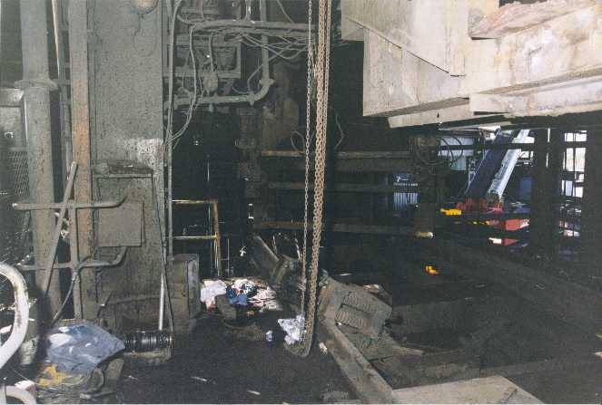

2.2 Police photograph No. 12 North west bearing assembly from north west corner
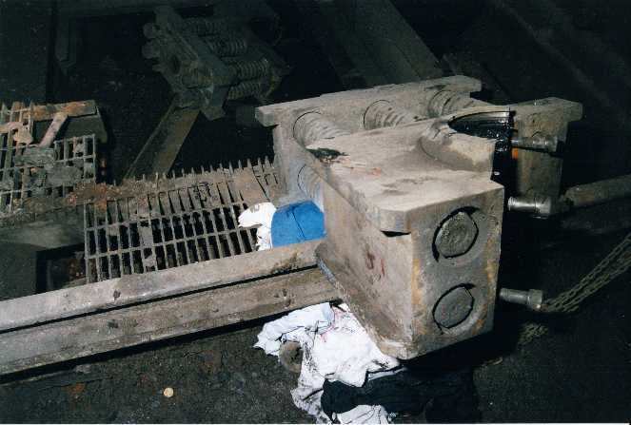

2.3 Police photograph No. 33 Bearing housing assembly on west rail

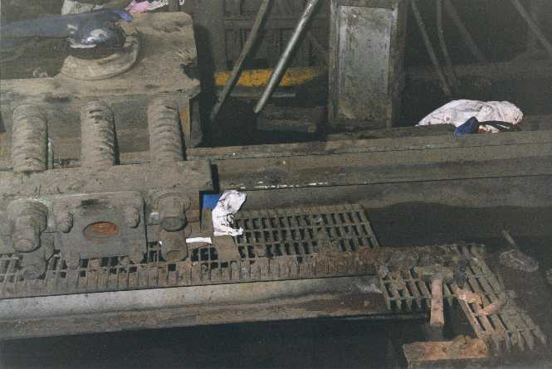

2.4 Police photograph No. 36 Looking up underneath of 223 level north west corner

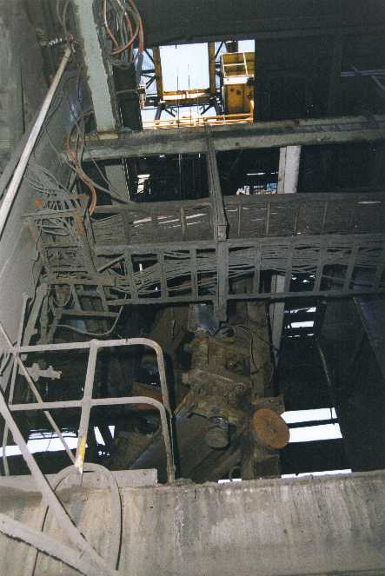

2.5 Police photograph No. 19 Accident scene and south east bearing housing assembly on 223 level.

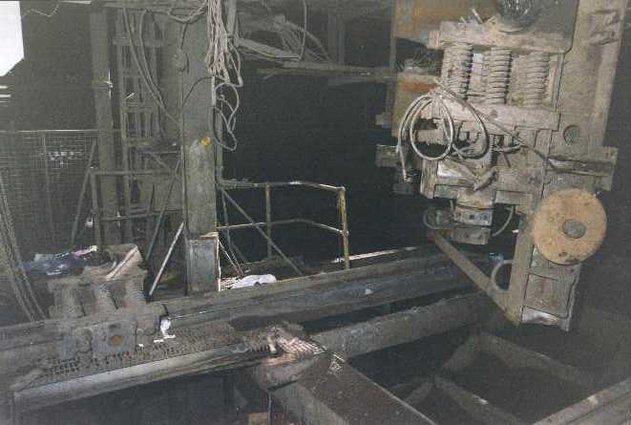

2.6 Police photograph No. 10 223 crusher frame from south east.

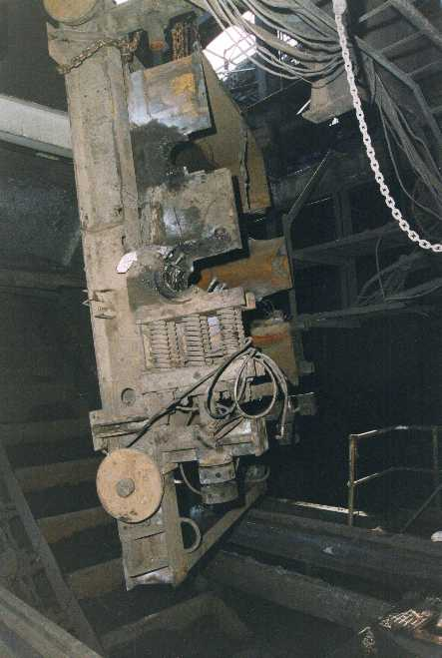

2.7 Police Photograph No. 11 North west bearing housing assembly

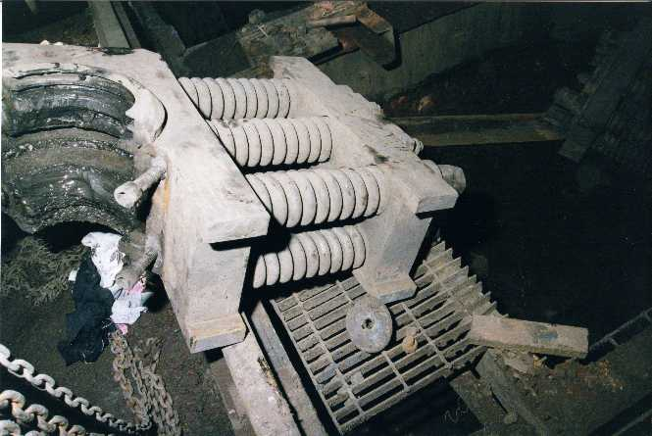

APPENDIX 3 MANUFACTURER’S LETTER CONCERNING THE 223 SPIKED ROLLS CRUSHER

APPENDIX 4 REPORTS BY:

Inspections X-Ray & Testing Pty Ltd (IXT).
- Examination and testing of the two northern take up screws and discs of the 223 spiked rolls crusher.

Bullivants Lifting & Safety Specialists
- Results of Onsite Weighing of Lead Smelter Crusher Components 20.07.00

Mechanical Inspector of Mines

APPENDIX 5 DOCUMENTATION ON:

5.1 A.E.T. Operations Pty Ltd / Baulderstone Hornibrook Health & Safety Management Plan

5.2 George Fisher Project – Contract No. BBK816-M-CC-32C, Smelter Sinter Plant Structural Mechanical

5.3 Lead Smelter Y2000 Shutdown – Risk Assessment

5.4 Lift Procedure – Removal of 223 Crusher by A.E.T. / BH

5.5 Manufacturer - Jaques Bros. Ltd. Engineers – Richmond Victoria drawings
- No. GW-28 – GENERAL ARRANGEMENT 30”x72” SPIKED ROLLS drawn on 29-6-59 and re-drawn 21-4-66, Rev. 4

- No. G-256 – G.A. of 30” DIA. X 72” SINTER ROLLS MT. ISA MINES, without date or revision,

- No. GY 24 TAKE UP SCREW, drawn 18-2-52

5.6 Simon-Carves (Australia ) Pty. Limited – Sydney. N.S.W drawing
- No. 163-6-8254 Rev. A – ARR’GT OF SPIKED ROLL CRUSHER NO. 223

5.7 Documents given to Glen CANNON by Kevin BOCOS on Tuesday 11 July 2000

5.8 Job Safety Analysis for the removal of 223 crusher by Torren BOCOS, A.E.T. Operations Pty Ltd Safety Adviser

APPENDIX 6 REGISTERED MINE MANAGER’S REPORT

APPENDIX 7 INVESTIGATION DOCUMENTATION

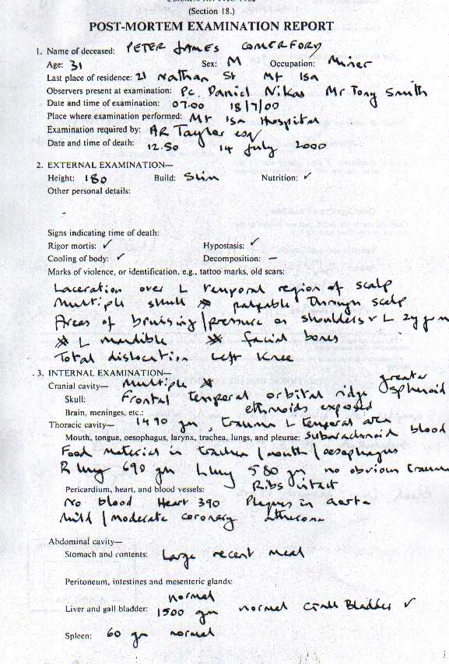
7.1 Post mortem examination report (Form 10)

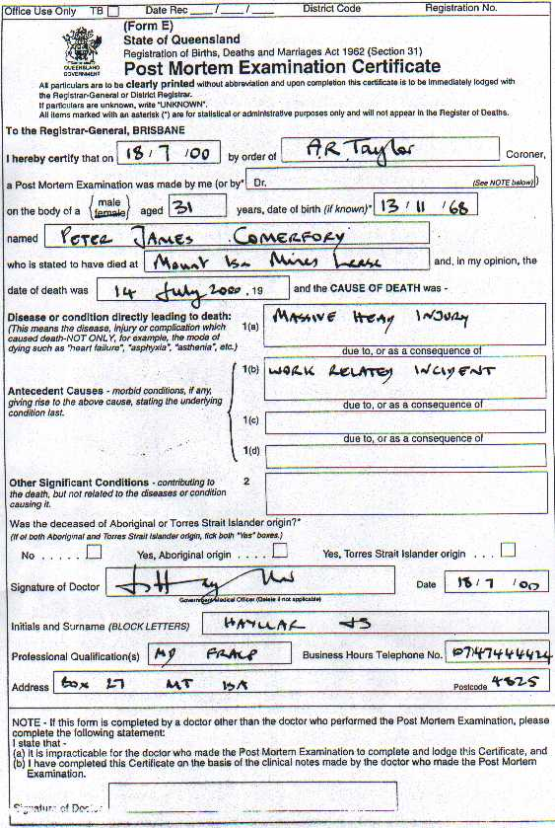
7.2 Post mortem examination certificate (Form E)

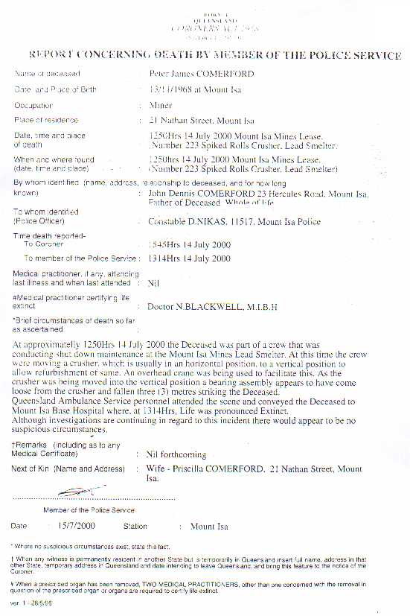
7.3 Report concerning death (Form 4)

7.4 Pathology report

INFORMATION NOT AVAILABLE AT THE MOMENT OF

PREPARING THIS REPORT

7.5 Toxicology report

INFORMATION NOT AVAILABLE AT THE MOMENT OF

PREPARING THIS REPORT

7.6 Death certificate

INFORMATION NOT AVAILABLE AT THE MOMENT OF

PREPARING THIS REPORT

APPENDIX 8 RECORD BOOK ENTRIES

14 July 2000 | Sergio CESPEDES
15 July 2000 | Sergio CESPEDES
18 July 2000 | Sergio CESPEDES
20 July 2000 | Sergio CESPEDES
21 July 2000 | Sergio CESPEDES
15 July 2000 | Richard HORSBURGH
16 July 2000 | Richard HORSBURGH
16 July 2000 | Richard HORSBURGH
17 July 2000 | Richard HORSBURGH
17 July 2000 | Richard HORSBURGH
27 July 2000 | Richard HORSBURGH
15 July 2000 | Hermann FASCHING
15 July 2000 | Hermann FASCHING
16 July 2000 | Hermann FASCHING
16 July 2000 | Hermann FASCHING
20 July 2000 | Hermann FASCHING
17 July 2000 | Peter McGARVEY
18 July 2000 | Peter McGARVEY
20 July 2000 | Peter McGARVEY
20 July 2000 | Peter McGARVEY

APPENDIX 9 APPOINTMENT OF REGISTERED MINE MANAGER

APPENDIX 10 PRELIMINARY REPORT TO THE CHIEF INSPECTOR OF MINES

