SAPPER ROBERT TEMPLETON
6065 – 1st Tunnelling Company

Robert Templeton stated he was born in Duloy, Northern Ireland about May 1887. He came to Australia and worked as a miner.

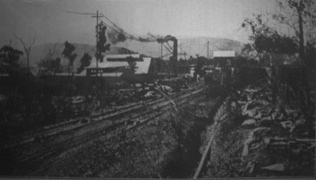
In 1907 Geological surveys found coal deposits in Mount Mulligan, North Queensland which pleased the mining companies in the region, as locally produced coke would reduce the costs of their smelters. Thorough surveys from the Assistant Government surveyor were finalised in 1911 allowing development to commence and four years later a railway was completed to the site. The Mount Mulligan Colliery was in full production in 1915.
Photo: Mount Mulligan Colliery c1917
Queensland Government Mining Journal October 1921

Robert Templeton was an employee of this Colliery and his address was listed as Mt Mulligan.
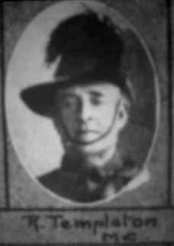
Photo: The Queenslander
October 28, 1916
At the Enlisting Office in Cairns, North Qld the twenty-nine year old coal miner applied to enlist for active service abroad on August 8, 1916. Personal particulars on his application reveal he was single and 169cms (5ft 6½ins) tall and passed the preliminary medical examination allowing Attestation forms to be completed the same day. Four days later his application was accepted by the Recruiting Officer and he signed and took the “Oath of Allegiance”.

Further information shows he weighed 66.8kgs (147lbs) with a chest measurement of 89cms (35ins). Dark was his complexion with brown eyes and brown hair and had good vision. Presbyterian was his religion. Next-of-kin was given as his brother Mr George Templeton of Ander, Planes, Scotland and later changed to Plainis, Aidrie, Scotland.

At the Enoggera Camp, Brisbane, Qld Private Templeton commenced basic training with the 11th Depot Battalion on August 18 until September 25, 1916 when he was sent to the Miners’ camp (1st Military District) for further instruction.

Declared dentally fit the same day he trained there until October 14, 1916. During his training Home Leave was granted before being transferred to the Miners’ Training Camp at Seymour, Victoria and assigned to the December 1916 Reinforcements. His regimental number was 6065 in the rank of Sapper.

The 516 Reinforcements departed Melbourne, Victoria on October 25, 1916 at 1.30pm aboard the transport HMAT A38 Ulysses. The Australian coastline disappeared from view on October 30, 1916 with the port of Durban reached at 11.30am on November 13, 1916. Windy weather going around the Cape arrived at Cape Town at 7am on November 19. Sierra Leone was the next port of call but their departure was delayed until December 14, 1916 as it was not safe to proceed further.
Arrived at Plymouth, England on December 28, 1916 after 65 days at sea, with the troops disembarking at 1.30pm and detrained to the station at Tidworth. They marched into the Aust. Details Camp at Perham Downs the next day for further training for the front.

The Reinforcements proceeded to France via Folkstone on January 28, 1917 on board S.S. Onward and marched into the Aust. General Base Depot the following day. On February 2, 1917 they were assigned to the 1st Anzac Entrenching Battalion which was an advanced section of the Base Depot that organised works near the lines and through duties would accustom the reinforcements to war conditions before being assigned to a company in the field.

Sapper Templeton proceeded on April 14, 1917 to the 1st Tunnelling Company and was attached in the field five days later.

Blue Chevrons were due to him for his service around this time.

On February 11, 1918 he was taken sick to the Field Ambulance suffering from contusions to his head caused accidentally and transferred to the 63rd Casualty Clearing Station. He rejoined his unit on February 24, 1918.

He was taken on strength with his unit on April 27, 1918. No further injuries, sickness or wounding occurred during the remainder of his service.

Leave was granted from August 18 until August 26, 1918.

When Armistice was declared he was with his unit and they remained as part of the Army of Occupation assisting with the rehabilitation of the country with repairs to roads and bridges.

Leave from France was taken from February 15 until March 1, 1919 and rejoined his unit on March 3, 1919. A month later on April 3 they were ordered to return to the A.G.B.D. to prepare for England marching out on April 10. Crossed the English Channel and the next day marched into the No. 1 Group Camp at Deverill to await their departure for Australia.

On May 31, 1919 Sapper Templeton embarked on H.T. Aeneas for the voyage home. The ship docked in Melbourne, Vic (3rd M.D.) on July 12, 1919 and he returned to Brisbane (1st M.D.) a few days later.

At the 6th Aust. General Base Depot on July 14, 1919 he was medically assessed and his report stated ‘no disability’ and was recommended for demobilisation.

In the London Gazette on July 11, 1919 Sapper Templeton was Mentioned by Sir D. Haig in his Despatches relating to conspicuous service.

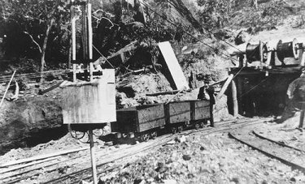
Military Discharge took place in Brisbane (1st M.D.) on August 21, 1919 and Robert Templeton returned to work at the Mount Mulligan Colliery.

Photo: Entrance to Mt Mulligan
Mine
Picture Queensland

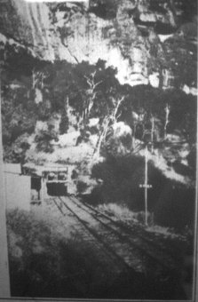
On October 22, 1919 the District Finance Officer, A.I.F. (1st M.D.) replied to the Dept of Defence’s request for the current address of Robert Templeton which was stated as Mt Mulligan, Q’land.
Photo: Run in to entrance of Mount Mulligan Colliery
North Queensland Register

A copy of the extract dated July 11, 1919 from the London Gazette relating to Sapper Templeton’s Mentioned in Despatches was sent to his brother on December 9, 1919.

Two Oak Leaves, one large and one small, representing the Mentioned in Despatches emblem were receipted as received by him on November 18, 1920.

On July 15, 1921 a Certificate for Mentioned in Despatches (4677) was acknowledged by him from his address at Mt Mulligan, via Cairns, N.Q.

The British War Medal (24506) and the Victory Medal (23679) were issued to Sapper 6065 Robert Templeton, 1st Tunnelling Company for service for his country.

Robert Templeton was killed while working his shift in the Mount Mulligan Colliery Explosion on September 19, 1921 aged about 34.

The following are photographs and extracts which record Queensland’s worst mining disaster:
North Queensland Register on Monday October 3, 1921

MOUNT MULLIGAN COLLIERY EXPLOSION
Mount Mulligan was the scene of the tragic explosion which occurred on Monday 19th September, at 9.22 a.m. in which every man in the mine lost his life, 75 being the total death roll.
Mr P. Ahern, who was one of the first rescue party from Cairns, in a conversation this morning, informed us (“Cairns Times”) that the identification of the various victims was made very difficult by the distorted features of the corpses, also by the fact that no proper record was in existence of where the men were working. Usually there was a complete records, but as cavilling (drawing lots) for places, which is done in the coal mines every three months, had taken place at the “fire station” in the tunnel that morning, it was not known what places they had allotted, no records having escaped the flames of the explosion, and the mine manager, who was seriously injured, and the men who were dead, were the only ones who knew to what faces the men had gone. Mr Ahern, who was through a large portion of the mine, also stated that there were clear indications that the intensity of the explosion had not been the same throughout the mine; some of the dead ends of the workings being very little effected. This was also borne out by the fact that some of the corpses were much scorched, whilst on others there were no traces of fire having touched them. Mr Markham, who was also one of the rescue men who entered the mine, said that he saw at least three men who had not been killed by the explosion, but had succumbed to the deadly poisonous ‘after damp.’ The three he saw had crawled a short distance up a low narrow unused drive, and were lying one at the feet of the other; but he had no doubt that they had been suffocated within a few minutes after the explosion.

These photographs show the power of the explosion with all the rubble in the foreground of the entrance to the mine collected as a result. Blown clear away was all the winding gear, concrete facing and ventilation housing. The tunnel ran in level for about 500 feet then dipped at about one in twelve for some considerable distance then branched north and south.

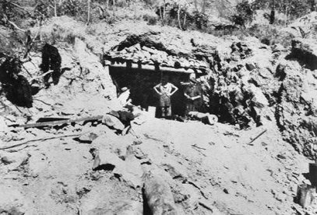
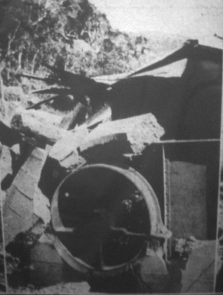
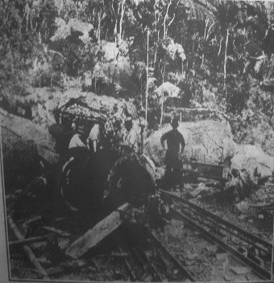
Photo Right: North Queensland Register October 3, 1921
Cable Drums, in foreground, are where they landed when blown away from their position at mouth of tunnel, a distance of over fifty feet. The electric motor control board and various other gear are distributed about.

Photo: Entrance after explosion - Picture Queensland
Photo Left: North Queensland Register October 3, 1921

An Exhaust Fan, at the outlet of the ventilation shaft. The outlet being on the left-hand side, and was connected with the fan by a concrete continuation wall of which were 9” or 10” thick. The force of the explosion blew all this to fragments and wrecked the motor house. Some slabs of concrete were blown a considerable distance down the hill. The air shaft outlet was situated about 200 feet to the left, and about 100 feet above the entrance to mine.
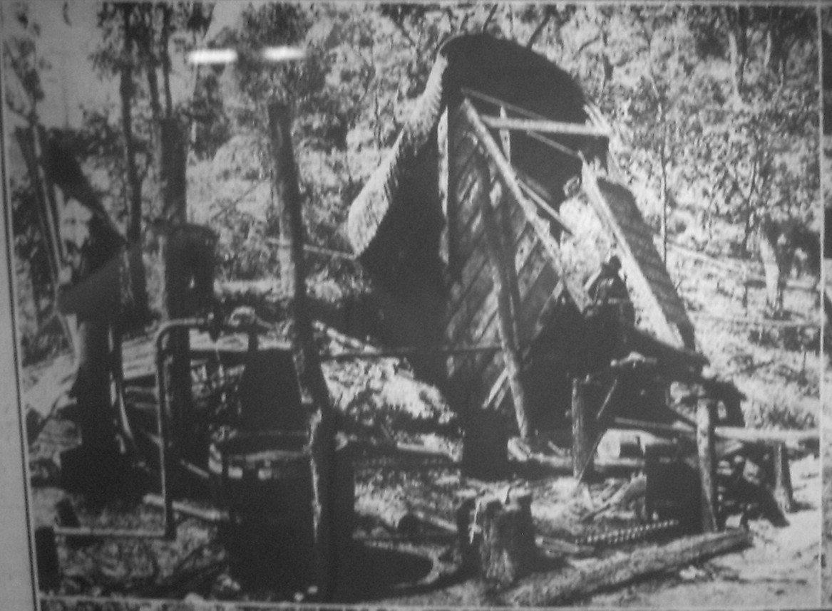
Photo: North Queensland Register October 3, 1921
The blacksmith workshop and electric switchboard House, situated 100 feet from entrance; little remains of the former, and the latter is blown over against the hill-side. The blacksmith was working at the moment of the accident and was also somewhat injured. The telephone, visible on one of the uprights, was attached thereto for communication with the men engaged in the mine recovering bodies.
The Brisbane Courier on Wednesday September 21, 1921 continues the account:

PATHETIC SCENES
RESCUE WORK AT MT. MULLIGAN
TWENTY-TWO BODIES RECOVERED
VERY LITTLE HOPE OF SURVIVORS
EXPLOSION ATTRIBUTED TO COAL DUST

Pathetic scenes were witnessed on Monday night and yesterday at the Mount Mulligan colliery pithead, where groups of men and women waited through the long hours in the hope that husbands, brothers, or sons, entombed as the result of the explosion, would be brought out alive. Rescue parties, although driven back frequently by gas or foul air, heroically worked with almost superhuman energy. So far the dead bodies of 22 miners have been recovered, and no hope of survivors is entertained.
[From our Special Representative]
MT MULLIGAN, September 20
All through the long weary hours of the night, and again to-day, pathetic scenes were witnessed at the pithead of the Mount Mulligan Colliery, where men, women, and children had assembled, hoping against hope that husbands, fathers, brothers or sons, who had been entombed as the result of the terrible explosion yesterday morning might be rescued alive.
THE TOWNSHIP
Mount Mulligan is a typical Australian mining camp. Two hotels, stores, iron humpies and calico tents comprise the township. The pit extends into the base of Mount Mulligan, which rises sheer and barren, standing like a gloomy tombstone over one of the most tragic graves Australia has ever known. Pathos is writ large over the scene—women and children weeping broken-heartedly, and men working frantically to occupy their minds—asking for work and more work to distract their thoughts from the terrible tragedy. The gas is still very bad. One dead horse which was seen by a rescue party this morning had been burnt black as a result of the explosion.

THE MINE
There is one entrance to the mine, and it is also used as the exit. The tunnel pierces the mountain for a distance of 700 or 800 yards. Another opening, which enters the mountain higher up, is used as an air channel. The highest point of Mount Mulligan is 1200ft above the colliery works, and 2400ft above the level of Cairns.
TWENTY-TWO DEAD BODIES RECOVERED
Up to 7 o’clock to-night 22 dead bodies had been recovered, and were identified as those of :
Robert Thompson R. Leary Thomas Mawes T. Hutton Louis Joachimzik
F. Pattinson T. Taylor Thomas Adams J. Carney W. Hutton
P. Minogue F. Latimer F. Gielis G. Hawes M. O’Grady
E. Risley N. Rumming -- Hawes J. Long -- McIntyre
T. Camm D. Hutton

ARRIVAL OF THE RELIEF TRAIN
The relief train arrived at Mount Mulligan at 10.30 last evening, after a journey lasting seven hours. A large crowd had assembled at the pithead. And the grief of the relatives of the entombed men was distressing to witness.

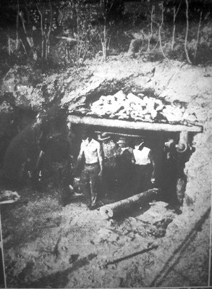
THE RESCUE WORK
Photo: The Stretcher Bearers
North Queensland Register October 3, 1921
All through the night picks and shovels were plied by relays of men with feverish activity, while others cleared away the debris. At about 11 o’clock a thrill ran through the waiting crowd of relatives as a body was borne from the mine. It was burnt black, and, with the exception of the boots, was destitute of clothing. The remains, which were scarcely recognisable, were identified as those of R. Thompson. A nerve-wracking period of suspense followed. It was not until 6.30 this morning that that further bodies were recovered and then six more were brought out. Five of the identified were those of Frank Gielis, L. Joachimzik, T. Adams, L. Liverside, and T. Hawes. The sixth was too charred to be identified definitely, but it was believed to be that of H. Bollen. About 7 o’clock two more were recovered and were identified as those of T. Carney and J. Fogarty, and later the dead bodies of T. M’Cann and J. Long were brought out.

DEATH WAS INSTANTAEOUS
Dr Clarke, of Cairns, who worked all night examining the bodies as they were brought from the mine, says that death was instantaneous. The unfortunate men apparently were burnt with the flames, and the doctor says, would die immediately from shock. Dr Clarke, is the only medical man here now, Dr Perkins, who had become exhausted, having returned to Mareeba yesterday. Ambulance Brigade superintendents returned to Cairns and Atherton respectively after having worked strenuously all night. Police Inspector Daley and Detective Tiernan of Cairns, were on duty all night at the entrance to the pit, assisting in the work of identifying the dead bodies.

THE EMTOMBED MEN
The following is a list of the men who were entombed, a number of whom have been already brought out dead:

R. Pattison H. Harrison H. Martin J. Henry J. Drier Snr
W. Thompson J. O’Halloran J. Fogarty J. Carson J. Drier Jnr
J. Fitzpatrick P. Conople R. Templeton P.W. Johnson J. Loughrie
J. Taylor G. Hawes J. Beattie T. Swift R. Thompson
J. Bell S. M’Colm F. Whelan J. Joachimzik H. Jackson
J. Cunningham W. Ostie D. M’Intyre F. Malbon G. Mounsey
A. Casloss J. Nixon T. Camm W. Kerr T. Adams
H. Mansfield J. Lawson T. Hutton W. Stevens R. Leary
J. Long J. Regan E. Risley J. Carney R. Spiers
P. Minogue J. O’Boyle G. Turniff P. Marks A. Hall
F. Gielis H. Bollen E. Hutton W. Fisher A. Leary
S. Liversidge S. Latimer J. Lomax T. Hawes T. Hynes
W. Running F. Pattison R. M’Cormack J. Reay P. Parkinson
F. Grant, shift boss G. James Snr M. O’Grady S. Butcher G. James Jnr
D. Butler F. Hadcock

T. Evans, the Mine Manager and W. Cole died several days later.

This was Queensland’s greatest land disaster and the consequences of the township’s losses not equalled in Australia until perhaps the Victorian bushfires of 2009. Statistics show Mount Mulligan lost about one adult out of three or one male in every two. Left to carry on were about 40 widows and 83 fatherless children.

The Brisbane Courier on Thursday September 22, 1921 reported the heart-rending situation of a petition from Mount Mulligan residents collected before the disaster.
FOR THE CHILDREN
Only a few days ago Mr J.H. Ryan M.L.A. had received a petition from Mount Mulligan for presentation to the Minister for Public Instruction asking that additional accommodation should be provided for the children of Mount Mulligan. This petition contains the name of miners, teamsters, carpenters, &c., and their wives. Many of those whose dead bodies have been recovered from the mine and whose children had been left fatherless.
The signature of miner R. Templeton appeared among those on this petition.

The Brisbane Courier on Friday September 23, 1921 published the names of another group of miners recovered which included Robert Templeton.
HEAVY DEATH TOLL
71 BODIES RECOVERED
REMAINDER LOCATED
MT MULLIGAN Sept 22
Up to 10 o’clock to–night the bodies of 71 out of 74 men entombed had been recovered, and the remaining three bodies were located before 11 o’clock, though at that time they had not been removed from the mine. Of the bodies recovered up to the present 20 have not been identified. Since 10 o’clock last night the following additional bodies have been identified:
J. Reay S. Morgan R. M’Cormack A. Hall
T. Adcock -- Fitzpatrick T. Parkinson S. Seymour
R. Templeton W. Smithson T. Hynes J. Simpson
A. Casloff R. Whelan
During the day rumbling noises were heard inside the mine. Difficulty is being experienced in recovering the remaining three bodies. A gang led by Inspector Laun and Warden Dunlop, went down to make a thorough exploration at 8 o’clock tonight, but it was not till three hours later that the bodies were found.

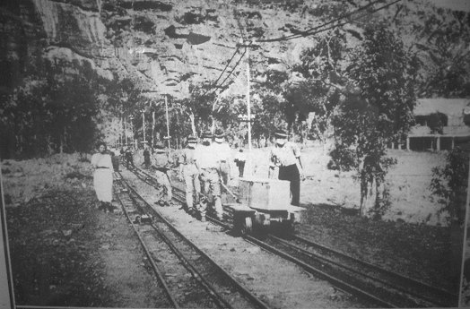
Photo: Day and night their relatives watched—and waited. When identifying was complete coffins were dispatched up the slope, often with the widow accompanying the coffin to the Township.
N.Q. Register October 3, 1921.

It was reported that the town did not have a cemetery to bury the victims therefore had to be established and ground be consecrated as victims were being recovered.
The Brisbane Courier on Friday September 23, 1921 reports:
THE BURIALS
The burials in the new cemetery now number 63—33 in the Church of England portion, including six unidentified; 12 in the Roman Catholic portion, including two unidentified; and 18 in the portion devoted to other denominations. Other bodies have been taken to Mareeba and Thornborough for burial.
Footnote: Interment was also in Cairns after this report.

The following articles were published during the Inquiry into the Explosion.

The North Queensland Register on Monday October 10, 1921
MT MULLIGAN October 3.
The members of the Mt Mulligan Commission made a further inspection of the mine to-day, this completing the investigation of the whole colliery.

The absence of gas in the mine is proved by the fact that naked lights were used throughout the investigations. The importance of the inquiry is fully recognised by the investigators, who are leaving no stone unturned to sift the cause of the explosion to the bottom, and to be in a position to advise preventative measures in other mines.

ROYAL COMMISSION OPENS INQUIRY
MT MULLIGAN October 4.
The Royal Commission, comprising Messrs Dunlop, Kilpatrick and Want, commenced their inquiry into the Mount Mulligan disaster to-day the following officials of the Mines Department Messrs Jackson, Stafford, Williams and Laun, were present, Mr Hamlyn Harris, solicitor of Cairns, watched the proceedings in the Company’s interests.
The first witness was Geo. Morrison, who was working in the blacksmith’s shop alongside the pit mouth; Morrison said he could not describe the explosion, though he heard it. He was rendered unconscious. There was no warning before the crash came from the tunnel mouth.

John Harris, a blacksmith, who was in the machine shop at the time of the explosion, said there was a second explosion about two seconds after the first. On his arrival at the tunnel he saw everything there was wrecked. The two winding drums near the mouth, weighing about two tons were blown 40 feet away, and the smithy was blown to pieces. The first two men got out were Evans, who was badly wounded and who had his throat badly burned, and O’Grady, who was partly conscious, and said something about being cold. O’Grady had a big wound on the side of his head, and was blackened as were the rest of the men. The tunnel was wrecked all the way along the roof and a lot of material was falling at times.

James T. Watson, general manager, stated he was in the coke works when he heard the heavy report and saw heavy smoke clouds coming from the main tunnel. Almost simultaneously a heavy blast came out of the tunnel, and a fraction of a second later another explosion was heard. With others he approached the tunnel, and noticed the grass for 50 yards in front of the tunnel was burnt. There was a heavy volume of after damp and smoke in the tunnel, which was badly damaged. The ground was appearing shaky, and it was impossible for anyone to enter so soon. After the damp retreated witness entered the pit, and one hundred yards in they recovered Evans, and O’Grady six feet further in. The latter spoke, asking to be taken to his cabin. The next found was Bob Thompson, who was dead. The after damp was too strong, and witness ordered all the men out of the mine. When he found there was no hope for lives, he devoted attention to clearing the mine of after damp. He realised the victims could not have got far from where they were working, as the after damp was very bad. Carbon monoxide was present the whole time.

James Harris, engineer gave a detailed account of rescue work.

William Mathews, who assisted in the rescue work, stated the Thompson appeared to have been killed through being forced on the side of the tunnel. Percy Marks appeared to have run into a gig gateway before being killed. In the Fitzpatrick section there were indications that an explosion had occurred which split both ways. A collar belonging to a pony was found 30 yards away up the hill.

Ernest Laun, mines inspector at Charters Towers, stated that of 12 bodies recovered in No. 12 dip two were found in No. 10 level, evidently running there after the accident happened, retreating from the flames. All the bodies were burnt. There was no appearance of violence. These 13 bodies, except two, were not within 50ft of the respective working places, indicating that warning must have been given. One body still remained in the mine.

MT MULLIGAN October 5.
The Mount Mulligan inquiry was advanced another stage today.

Mr Laun reply to Mr Kilpatrick, said he thought it would be wise that breathing apparatus should be installed in the district for use in rescue work.

Replying to Mr Dunlop, Mr Watson said he always considered Mount Mulligan one of the safest mines in Queensland. All open lights were used, mostly acetylene. He saw explosives lying about in the mine, apparently scattered by the explosion.

Mr Want asked: Can you say you were not appalled at the way the explosives were scattered about?
Mr Watson: The explosion was apparently responsible.

Regarding coal dust danger, Mr Watson said dust must be floating in the air before causing the explosion. Then it had to be ignited by light alone. It required concussion besides intense flame.

Replying to Mr Want, Mr Watson said he thought dust was a greater menace than gas under certain conditions. Abridged

MT MULLIGAN October 6.
A party of eight miners entered the pit to-day to locate the body of victim, supposed to be Butler, still remaining underground. The body was located, but owing to the great amount of fallen ground in the vicinity, the recovery will not be affected for a few days.

At the resumed inquiry to-day evidence was given respecting the use of explosives in the mine.

Geo Williams, an experienced miner, stated he considered the management careless in the matter of the way explosives were carried into the mine and generally handled.

W. Mathews, a machine man, stated the blasting holes were tamped with coal borings or sand. Mathews said once when dust was complained of in one particular place, Deputy Grant said it would have to be remedied, thus admitting its presence was a menace.

Mine Inspector Williams, in his evidence, stated that he inspected the whole of the workings in March last, paying particular attention to the explosives which he found laying about the pit road unprotected, together with caps. Witness ordered that the procedure would have to be altered and the caps and explosives kept in separate boxes, and he also reported that the mine had reached a stage when shot-firers should be appointed. At the time of the inspection he did not consider the dust on the roof pit dangerous and thought an accident would be an off-chance.

He had thoroughly inspected the mine since the disaster and would say the explosion originated from coal dust. Witness said Mr Evans was a strict man and would tolerate no dangerous practices.

Mr Laun stated that after a thorough inspection of the mine since the explosion he considered there was abundance evidence that the explosives were not being properly stored. Caps and explosives were mixed in the same boxes. He never saw explosives treated with such familiarity at Mount Mulligan. Mr Evans told him he never saw traces of gas in the mine.

MT MULLIGAN October 7.
The Mt Mulligan Commission resumed its inquiry to-day.
Mr Jackson, Chief Inspector of Mines, was the chief witness. His evidence was mostly of a technical nature dealing with the use of explosives in mines. He considered the use of coal dust for tamping blasting holes was a source of danger, as there was a possibility of an explosion igniting the dust as it blew out. He did not think it possible an ordinary naked light would ignite the dust, but he thought acetylene gas was a source of danger. He considered the Mining Act should be amended to read that only permitted explosives be used in collieries with no exception to the rule.

The inquiry adjourned until Saturday.

North Queensland Register on Monday October 17, 1921
MT MULLIGAN October 9.
Before proceeding with the evidence on Saturday morning, members of the commission made a further inspection of the mine for the purpose of clearing up the few points which came out in evidence.

On the resumption of evidence, Mr Stafford, inspector of mines at Ipswich, gave detailed evidence of his inspection of the mine, in the course of which he stated that the one place suggesting the origin of the explosion to him was in the top workings where a machine was stationed. Asked by a member of the commission for his suggestion to prevent a recurrence of a like disaster, Mr Stafford stated that regarding use of explosives he would suggest a limit to the time of firing also the permitting of explosives only to be used additionally for shot firing. The regulations should be strictly observed regarding lighting. It was an established fact that an open light would ignite dust. Only approved lights should therefore be used. If electric lights were used throughout the mine others should be used for testing purposes. Questioned as to what he thought of the manner in which explosives were handled at Mount Mulligan, Mr Stafford replied that the evidence pointed to an irregular method of handing, distribution and storage at the faces. As inspector of mines, at Ipswich he would allow nothing of the kind to obtain in that district. Abridged.

MT MULLIGAN October 10
The miners, who were searching for the body of Donald Butler, believed to be still entombed, have been withdrawn from the enterprise, after three days’ unsuccessful search. The spot where the body was supposed to be was reached and thoroughly cleared, but there was no trace of the missing man. No likely place in the mine now remains unexplored. Whether a further search will be made, including unlikely places, is a matter not yet decided. The evidence tendered at the inquiry showed 75 men entered the pit on the morning of the accident, and 74 bodies were recovered. The question now presenting itself is whether it is possible some mistake occurred in either tally, the only alternative being that the body remains unrecovered. It is commonly believed however, that one body still remains in the mine.

There was a touching sight at Mt. Mulligan cemetery yesterday afternoon, when a number of widows visited the graves of their late husbands.

One or two suffered almost a complete breakdown, and were consoled by their grief-stricken sisters in trouble.

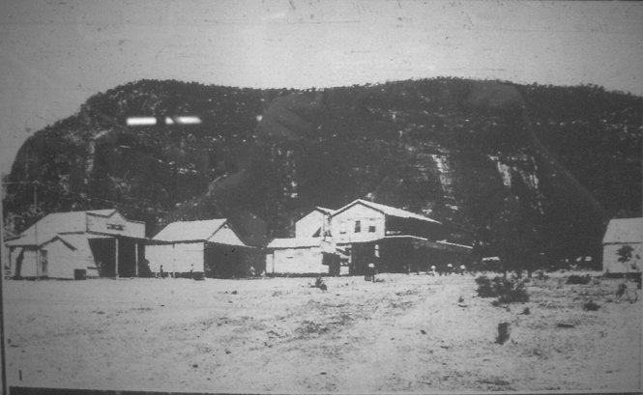
Before leaving the scene, the Royal Commissioner and the Mines Department official visited the cemetery, Mr Kilpatrick afterward visiting the widow of McColm, who is left with five children. Abridged.
Photo: Mount Mulligan Township as seen from the targets at the Rifle Range – Qld Government Mining Journal, 1921

Mr Peter Bell, BA (Hons) who published a book on The Mount Mulligan Disaster (1978) stated that seventy-four bodies were retrieved and of those twelve were unidentifiable. When the mine reopened five months later the remains of last man was found on February 8, 1922. In the course of his research he said Edward Morgan was the miner to whom the Royal Commission attributed much of the blame for the Mount Mulligan explosion. Bell considered the evidence advanced by the Royal Commission insufficient to establish Morgan’s culpability and the means of initiation of the explosion remained unexplained. He was also not convinced of the conclusive number of dead. A weight of contradictory evidence suggested to him the number may have been 76.

Robert Templeton’s body was identified and buried in the Mount Mulligan cemetery.

A month later on November 4, 1921 Mr G.J. Templeton of Belmore Street, Wollongong, NSW wrote to Base Records after receiving a letter dated October 10, 1921. It reads:

“I have received a letter from Mr J.T. Watson from Mt Mulligan Chillagoe Limited, Queensland, re the Robert Templeton, who lost his life in the late mine disaster. Your description would seem to indicate that he was your brother as he was a Returned Soldier and in other respects agreed with your description. The Police have taken possession of his belongings, signed by J.T. Watson, Superintendent Engineer.”

“I also received a wire from the Chief Commissioner of Police from Brisbane, Queensland, which reads:

“Re Robert Templeton killed Mt Mulligan mine disaster, single, returned soldier, Military number 6 ought 6 5, Brother Aidre or Daidre, Scotland.

“The only difference in the wire as from the Police is the military number, with every thing corresponds to my brother Robert Templeton bar the military number, as I think my brother’s was 2893 2nd Light Horse, with service in Egypt in the A.I.F. forces. But there may be a mistake in the Military number which the police sent me as it seems to be a very queer thing for these two fellows with either one of them to have lost his life, to have a brother the same as my brother and a returned soldier and single. Sir, would you kindly send me a copy of Private Robert Templeton, Second Light Horse 2893 Military Discharge which enlisted from Enoggera Queensland I think and went away.”

Base Records replied on November 16, 1921 stating that they held records for both 6065 Robert Templeton, 1st Tunnelling Company and well as his brother 2893 Robert Templeton, 2nd Machine Gun Squadron who returned to Australia on the H.T. Madras and was discharged in Sydney in September 1919. The writer advised that Sapper Templeton was discharged in Brisbane in August, 1919 and gave his address as Mt Mulligan, Qld and there appeared to be no doubt, in view of the contents of the telegram sent you by the Commissioner of Police, Brisbane but that he was the victim of the mining disaster referred to. He was a coal-miner prior to enlistment, and his next-of-kin resides in Aidrie, Scotland. He was also shown as a single man. Information regarding his brother’s address could be ascertained by communicating with Headquarters, 2nd District Base, Victoria Barracks, Sydney, asking for the latest information from his War Gratuity application.

A Memorial was erected by the Mining and Energy Union in the Mount Mulligan cemetery commemorating the 75th Anniversary of the 75 miners who perished in the Colliery’s explosion.

© Donna Baldey 2010
www.tunnellers.net

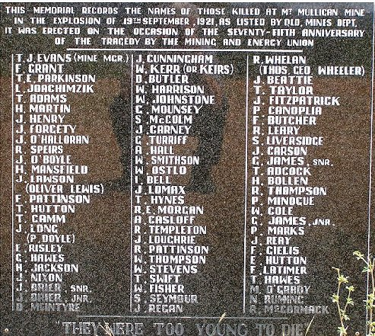
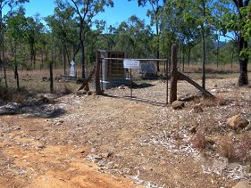
Photograph of Mt Mulligan Cemetery by kind permission of
Leighann Mansfield

